Cycle B 2022-2023
 | A1 | A2 | Sp1 | Sp2 | Su1 | Su2
SF | I wonder where it comes from…  Farm/ food link to harvest/  Trails/Maps (geography) – Little Red Hen map  Book focus: Shelly hen, Little Red Hen, Oliver’s vegetables, Handa’s Hen (The World)  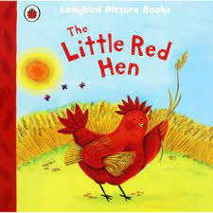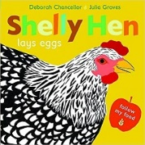  Local walk, farm visit, egg farm visit  Art - Andy Goldsworthy – natural art & colour mixing skills  The World: Human body – Oral Health (senses) teeth cleaning, naming parts of the face  The World: Forces and movement – farm, machines and how they move  Special occasions: Harvest  Weekly Outdoor Schools  Creating trails outside, clay on trees (faces – naming parts),  Andy Goldsworthy art | I wonder what is in there…  Enchanted world (geography)  Book focus: Stickman, The Something, The Gruffalo The Mole who knew it was none of his business, Hansel and Gretel, Owl Babies  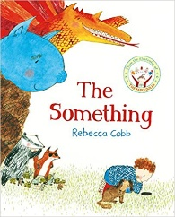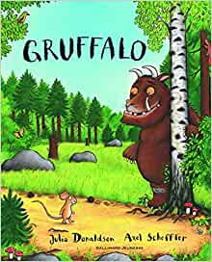  Woodland walk – Heligan  DT – Woodwork – Christmas decoration  I wonder why we use light…  Celebrations/ Past and present  Book focus: Peepo  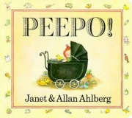  Special occasions: Christmas songs  The World: Electricity  Weekly Outdoor Schools  Stick art, exploring the woodland area | I wonder how big is big…  Dinosaurs/ Mary Anning (history)  Book focus: Dinosaurs who pooped a planet, Dinosaur Dreams Funnybones, Dinosaur lady  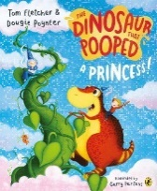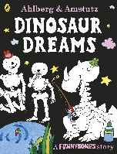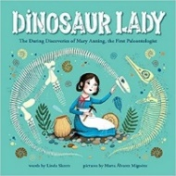  Science week (March 10th – 19th) – dinosaur workshop  The World: Animal and human bodies  Book focus: The Magic Paintbrush  Art – The magic paintbrush (colour mixing)  Weekly Outdoor Schools  Creating dinosaurs using natural materials; clay imprints using natural materials | I wonder when it grows…  Plant Hunters  George Forrest (history)  Book focus: The Tiny Seed, Jack and the Beanstalk, Hungry Caterpillar  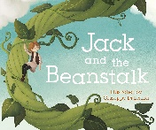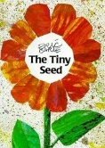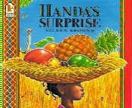  Caerhayes Castle visit  Special occasions: Mother’s Day  Easter  DT – Flower Art (Mother’s day)  Art - Van Gogh – Sunflowers (colour mixing)  The World: Plants  Weekly Outdoor Schools  Gardening, plant spotting and identification | I wonder what makes it move…  Superheroes/ Machines  Mae Jemison - first black woman to go to Space (history)  Book focus: Supertato, Superworm  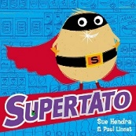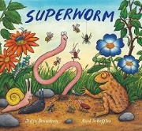  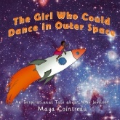  Special Occasions: Father’s day  DT – Woodwork – Something that moves  The World: Float & Sinking  Forces & Movement - Rocket launching – Science  Weekly Outdoor Schools  Obstacle courses | I wonder who lives there…  Beach/ Seaside (geography)  Book focus: Sharing a shell, Sally and the Limpet, Pirates love underpants,  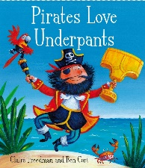  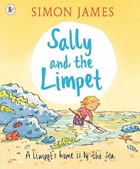  Art - Alma Thomas – Circles  Special occasions: Feast Week  Sports day  Home visits  The World: Animals and their habitats  The World: Floating and sinking  Weekly Beach Schools  PSTT lesson focus

