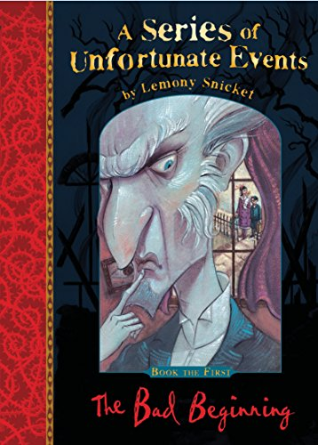
Spring 2 Unit Planning Overview for The Bad Beginning
The author:
Lemony Snicket was born before you were and is likely to die before you as well. He was born in a small town where the inhabitants were suspicious and prone to riot. He grew up near the sea and currently lives beneath it. Until recently, he was living somewhere else. A studied expert in rhetorical analysis, Mr Snicket has spent the last several eras researching the travails of the Baudelaire orphans. Lemony Snicket published his first book in 1999 and has not had a good night's sleep since. Mr Snicket is the author of quite a few books, all dreadful, and has been falsely accused of many crimes, all falsely. Once the recipient of several distinguished rewards, he is now an escapee of several indistinguishable prisons. He is widely regarded as one of the most difficult children's authors to capture and imprison.
By the end of this unit I will be able to write…
Setting Description (contrast between Justice Strauss and Count Olaf’s house)
Re-tell a famous fairy tale or story in the style of Lemony Snicket
Literary devices I will be practising throughout this writing journey:
- Revise key SPaG taught in Autumn Term
- Colons to mark the boundary between clauses: It’s sunny: I’m going out to play. Colons for dramatic effect.
- Semicolons to mark the boundary between clauses: It’s raining; I’m fed up
- Hyphens for compound words to avoid ambiguity: man eating shark or man-eating shark
- Personification
- Persuasive devices
- Synonyms:
- Realising that when you find a synonym, the word means something slightly different, eg,“big” and “grand”. “Grand” can mean “one thousand”, “elaborate” and “decorative”, as well as “big”.
- Antonyms to create different effects in sentences
- Antonyms: using prefixes
- Connectives to signpost and create cohesion within a text:
order of sequence, time connectives, additional ideas, space and place, contrasting, exemplification, results, to summarise
- Colon and bullet points for a list
- Repetition for effect: persuasion, suspense, emphasis
- Collective nouns
- Imperative verbs
- Modal verbs/adverbs of possibility

Other writing opportunities that will help me practise my skills:
Villainous Characters description
Book Blurb:
Dear Reader,
I'm sorry to say that the book you are holding in your hands is extremely unpleasant. It tells an unhappy tale about three very unlucky children. Even though they are charming and clever, the Baudelaire siblings lead lives filled with misery and woe. From the very first page of this book when the children are at the beach and receive terrible news, continuing on through the entire story, disaster lurks at their heels. One might say they are magnets for misfortune
In this short book alone, the three youngsters encounter a greedy and repulsive villain, itchy clothing, a disastrous fire, a plot to steal their fortune, and cold porridge for breakfast
It is my sad duty to write down these unpleasant tales, but there is nothing stopping you from putting this book down at once and reading something happy, if you prefer that sort of thing.
With all due respect,
Lemony Snicket

