Sea Turtles Long Term Plan
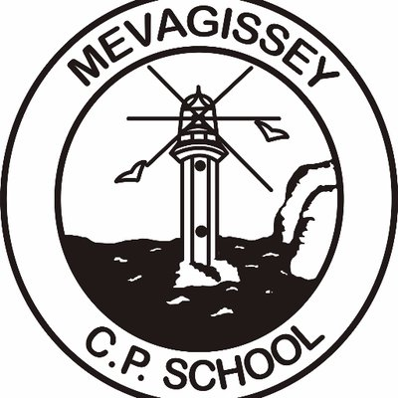
Term | Autumn 1 |  | Autumn 2 |  | Spring 1 |  | Spring 2 | Summer 1 |  |  | Summer 2
Topic | 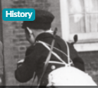  A child’s war |  | Sustainable Living |  | 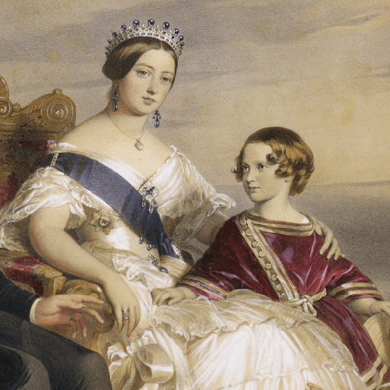  Revolution |  | 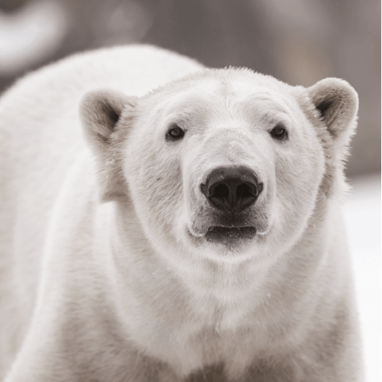  Frozen Kingdom | UK Trading |  |  | 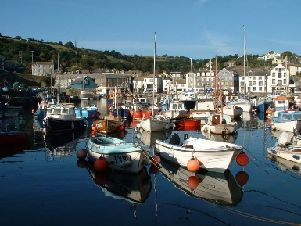  Our Mevagissey
Class Text/s | Reading for Pleasure:  Time Travelling with a Hamster – Ross Welford |  |  |  | Reading for Pleasure:  Street Child by Bertie Doherty  Shackleton’s Journey |  |  | Reading for Pleasure:  Can you see me?  By Libby Scott and Rebecca Wescott
Novel Study | Holes  Fiction:  Wild West Adventure Story  Non-fiction:  Diary Entry (recount)  Non-chronological Report  Travel Brochure  Literacy Shed:  The Alchemist’s Letter  Poetry:  Missing Line by Benjamin Zephaniah and Let there be Peace by Lemn Sissay Poems on a Theme (Black Lives Matter) |  | War Horse  Pamphlet about the requisition of horses to be used at the front line  War Letters (informal letters)  Story from an animal’s perspective  Literacy Shed Link: Beyond the Lines  Poetry:  Dreadful Menace (Literacy Shed) |  | A Series of Unfortunate Events  Fiction:  Setting Description  Villainous Characters  Studying Lemony Snicket’s Writing Style  Re-tell a famous fairy tale or story in the style of Lemony Snicket  Non-fiction:  Biography for Count Olaf  Literacy Shed:  Road’s End  Poetry:  The Highway Man |  | The Wolf Wilder  Fiction:  Action Scene (3rd Person, past tense)  Prediction Writing (writing an effective ending to a story)  Non-fiction:  Persuasive Letter  Instructions  Newspaper Report  Poetry:  Artistry by Michelle Pond | The Arrival  Fiction:  Poem on a theme (loneliness)  Step into a picture or re-telling of Chapter 1  Non-fiction:  Letter Writing (formal and informal)  Balanced Arguments  Recount - arriving in a new, unfamiliar setting (1st Person)  Literacy Shed:  The Catch |  |  | Stormbreaker  Fiction:  Escape Scene  Non-fiction:  Designing Spy Gadgets  Poetry:  Jabberwocky
Science | Light |  | Earth and Space |  | Evolution & Inheritance |  | Living things and their | Electricity |  |  | Animals including humans
Geography | No Geography focus this ½ term |  | Sustainable Living |  | No Geography focus this ½ term |  | Frozen Kingdom | UK links to the trading world |  |  | No Geography focus this ½ term
Design Technology | No DT focus this ½ term |  | To create a cooked dish using ingredients that are similar to those grown at Punta Mona. |  | No DT focus this ½ term |  | Structure:  Playgrounds  (Kapow) | No DT focus this ½ term |  |  | NOT ON C MAP
Art and Design | Kapow; Yr 6 Photography |  | No Art focus this ½ term |  | Make my voice heard  Artwork of artists Picasso and Kollwitz  (Kapow Y6) |  | No Art focus this ½ term | Kapow: Still Life |  |  | No Art focus this ½ term
History | World War 2 |  | No History focus this ½ term |  | Victorian Era |  | No History focus this ½ term | No History focus this ½ term |  |  | Museum Project
P.S.H.E. | Being Me in My World |  | Celebrating Differences |  | Dreams and Goals |  | Healthy Me | Relationships |  |  | Changing Me
R.E. | Christianity:  Beliefs and Meanings |  | Christianity:  Do Christmas celebrations and traditions help Christians understand who Jesus was and why he was born? |  | Islam:  What is the best way for a Muslim to show commitment to God? |  | Christianity:  Is Christianity still a strong religion 200 years after Jesus was on earth? | Islam:  Does belief in Akhirah (life after death) help Muslims lead good lives? |  |  | Islam:  Does belief in Akhirah (life after death) help Muslims lead good lives?
Music | Happy! |  | Classroom Jazz 2 |  | A New Year Carol |  | You’ve Got a Friend | Music and Me |  |  | Reflect, Rewind and Replay
Maths | Unit 1: Place value within 10,000,000  Unit 2: Four Operations (1)  Unit 3: Four Operations (2) | Unit 3: Four operations (2)  Unit 4: Fractions (1)  Unit 5: Fractions (2)  Unit 6: Geometry – position and direction |  | Unit 7: Decimals  Unit 8: Percentages  Unit 9: Algebra  Unit 10: Measure – imperial and metric measures |  | Unit 11: Measure – perimeter, area and volume  Unit 12 – Ratio and proportion  Unit 13: Geometry – properties of shapes. |  |  | Unit 14: Problem solving | White Rose Projects
P.E. | Football | Dodgeball |  | Gymnastics |  | Tag Rugby |  |  | Cricket | Athletics
MFL  French | Unit 19 – More about school | Unit 20 – Our world |  | Unit 21 – Describing people and things |  | Unit 22- Technology |  |  | Unit 23 – The environment | Unit 24 - Hygiene
Computing | Communication (Teach computing)  Partner units  Purple Mash Unit 6.2  Online Safety  Purple Mash Unit 6.6  Networks | 3D modelling (teach computing)  Partner units  Purple Mash  2Design & Make |  | Web page creation  Partner units  Purple Mash Unit 6.4  Blogging |  | Spreadsheets  Partner units  Purple Mash Unit 6.9  Spreadsheets |  |  | Programming A – Variables in games  Partner units  Purple Mash Unit 6.5  Text Adventures | Programming B – Sensing  Partner units  Purple Mash Unit 6.1  Coding

