Cycle A 2023 – 2024
 | A1 | A2 | Sp1 | Sp2 | Su1 |  | Su2
Starfish 1 | - Everyday materials (Y1)  distinguish between an object and the material from which it is made  identify and name a variety of everyday materials, including wood, plastic glass, metal, water, and rock  describe the simple physical properties of a variety of everyday materials  compare and group together a variety of everyday materials on the basis of their simple physical properties  CPD – Everyday Materials  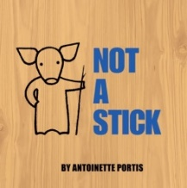 | - Seasonal changes (Y1)  Autumn/ Winter  observe changes across the 4 seasons  observe and describe weather associated with the seasons and how day length varies  CPD – Seasonal Changes  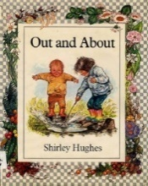 | - Plants (Y1)  identify and name a variety of common wild and garden plants, including deciduous and evergreen trees  identify and describe the basic structure of a variety of common flowering plants, including trees  CPD – Plants  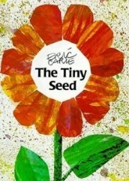 | British Science Week 8-17th March – Time  - Seasonal changes (Y1)  Spring/ Summer  observe changes across the 4 seasons  observe and describe weather associated with the seasons and how day length varies  CPD – Seasonal Changes  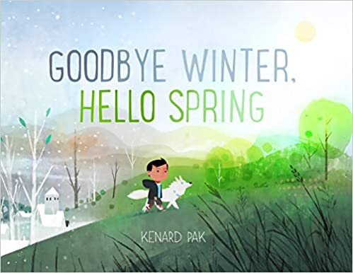 | - Animals including humans (Y1)  identify, name, draw and label the basic parts of the human body and say which part of the body is associated with each sense  CPD – Humans and other animals  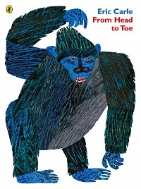 |  | - Animals including humans (Y1)  Seashore science lessons (PSTT)  identify and name a variety of common animals including fish, amphibians, reptiles, birds and mammals  identify and name a variety of common animals that are carnivores, herbivores and omnivores  describe and compare the structure of a variety of common animals (fish, amphibians, reptiles, birds and mammals including pets)  CPD – Living things and habitats  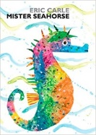
Dolphins 2 | Great fire of London  - Use of everyday materials (Y2)  identify and compare the suitability of a variety of everyday materials, including wood, metal, plastic, glass, brick, rock, paper and cardboard for particular uses  find out how the shapes of solid objects made from some materials can be changed by squashing, bending, twisting and stretching  CPD – Everyday Materials  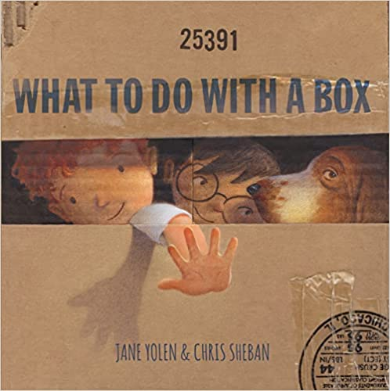 | Oceans and continents  - Animals including humans (Y2)  describe the importance for humans of exercise, eating the right amounts of different types of food, and hygiene  find out about and describe the basic needs of humans, for survival (water, food and air)  CPD – Humans and other animals  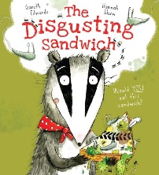 | Magnificent Monarchs  - Plants (Y2)  observe and describe how seeds and bulbs grow into mature plants  find out and describe how plants need water, light and a suitable temperature to grow and stay healthy  CPD – Plants  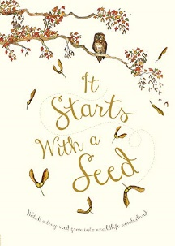 | Zambia – Contrasting Locality  British Science Week 8-17th March – Time  - Animals including humans (Y2)  notice that animals, including humans, have offspring which grow into adults (lifecycles)  consolidate the basic needs of animals for survival (water, food and air)  compare to needs of humans  CPD – Humans and other animals  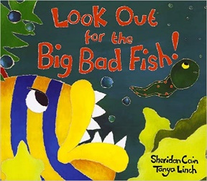 | Dinosaur planet  - Living things and their habitats (Y2) – school grounds  explore and compare the differences between things that are living, dead, and things that have never been alive  identify that most living things live in habitats to which they are suited and describe how different habitats provide for the basic needs of different kinds of animals and plants, and how they depend on each other  identify and name a variety of plants and animals in their habitats, including microhabitats  CPD – Living things and habitats  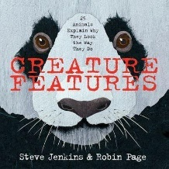 |  | United Kingdom  - Living things and their habitats (Y2)  Seashore Science lessons (PSTT)  identify that most living things live in habitats to which they are suited and describe how different habitats provide for the basic needs of different kinds of animals and plants, and how they depend on each other  identify and name a variety of plants and animals in their habitats, including microhabitats  describe how animals obtain their food from plants and other animals, using the idea of a simple food chain, and identify and name different sources of food  CPD – Outdoor Science  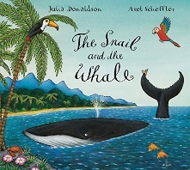
Lobster 3 | Early civilisations and Ancient Egypt  - Rocks (Y3)  Group different rocks, how they are formed.  Fossils – how they are formed.  Focus on plate tectonics etc  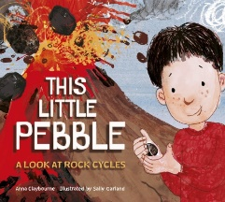 | Climate zones  - Forces and Magnets (Y3)  compare how things move on different surfaces  notice that some forces need contact between 2 objects, but magnetic forces can act at a distance  observe how magnets attract or repel each other and attract some materials and not others  compare and group together a variety of everyday materials on the basis of whether they are attracted to a magnet, and identify some magnetic materials  describe magnets as having 2 poles  predict whether 2 magnets will attract or repel each other, depending on which poles are facing  CPD – Forces and Magnets | Through the ages  - Animals including humans (Y3)  Identify animals (humans) need right types and levels of nutrition, cannot make own food, nutrition comes from what they eat  Identify humans and some animals have skeletons and muscles for support, protection and movement  CPD – Food and Feeding/ Body Systems  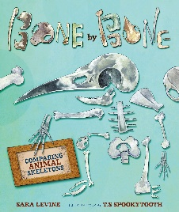 | South America: The Amazon basin  British Science Week 8-17th March – Time  - Plants (Y3)  identify and describe the functions of different parts of flowering plants: roots, stem/trunk, leaves and flowers  explore the requirements of plants for life and growth (air, light, water, nutrients from soil, and room to grow) and how they vary from plant to plant  investigate the way in which water is transported within plants  explore the part that flowers play in the life cycle of flowering plants, including pollination, seed formation and seed dispersal  CPD – Plants and growth  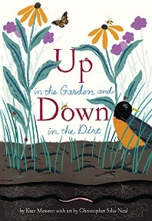 | I am warrior (ILP CS)  - Light (Y3)  Light is needed to see and dark is the absence of light, notice light is reflected from surfaces, light from the sun can be dangerous, ways to protect eyes, shadows are formed when light from a light source is blocked, shadow sizes changing  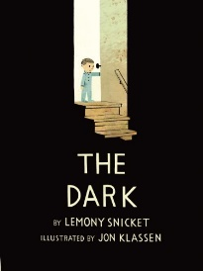 |  | Emperors and Empires (KRP-CS)  - Living things and their habitats  Seashore Science lessons (PSTT)  recognise that living things can be grouped in a variety of ways  explore and use classification keys to help group, identify and name a variety of living things in their local and wider environment  recognise that environments can change and that this can sometimes pose dangers to living things  CPD – Environments and Habitats  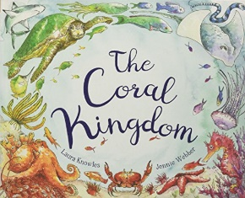
Jellyfish 4 | Traders’ and raiders  - Light (Y3)  Light is needed to see and dark is the absence of light, notice light is reflected from surfaces, light from the sun can be dangerous, ways to protect eyes, shadows are formed when light from a light source is blocked, shadow sizes changing  CPD – Light  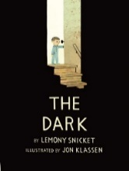 | What is a mountain?  - Rocks (Y3)  Group different rocks, how they are formed.  Fossils – how they are formed.  Focus on plate tectonics etc  CPD – Rocks and Soils | Invasion  - Sound (Y4)  How sound is made, how it travels, pitch and volume.  CPD – Sound  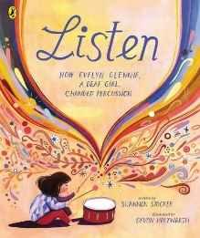 | Rio and South Brazil  British Science Week 8-17th March – Time  - Living things and their habitats (Y4)  (local environment: field/woodland/hedgerows)  recognise that living things can be grouped in a variety of ways  explore and use classification keys to help group, identify and name a variety of living things in their local and wider environment  recognise that environments can change and that this can sometimes pose dangers to living things  CPD – Environments and Habitats | Mevagissey – a harbour to call home  - Animals including humans (Y3)  Identify animals (humans) need right types and levels of nutrition, cannot make own food, nutrition comes from what they eat  Identify humans and some animals have skeletons and muscles for support, protection and movement  CPD – Food and Feeding/ Body Systems |  | North America  - Living things and their habitats (Y4)  Seashore Science lessons (PSTT)  recognise that living things can be grouped in a variety of ways  explore and use classification keys to help group, identify and name a variety of living things in their local and wider environment  recognise that environments can change and that this can sometimes pose dangers to living things  CPD – Environments and Habitats
Seals 5 | How Mysterious were the Maya?  - Earth and Space (Y5)  describe the movement of the Earth and other planets relative to the sun in the solar system  describe the movement of the moon relative to the Earth  describe the sun, Earth and moon as approximately spherical bodies  use the idea of the Earth’s rotation to explain day and night and the apparent movement of the sun across the sky  CPD – Earth and Space  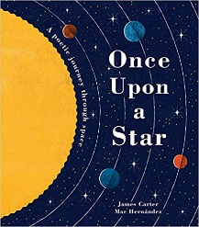 | Rivers  - Properties and changes of materials (Y5)  compare and group together everyday materials on the basis of their properties, including their hardness, solubility, transparency, conductivity (electrical and thermal), and response to magnets  know that some materials will dissolve in liquid to form a solution, and describe how to recover a substance from a solution  use knowledge of solids, liquids and gases to decide how mixtures might be separated, including through filtering, sieving and evaporating  give reasons, based on evidence from comparative and fair tests, for the particular uses of everyday materials, including metals, wood and plastic  demonstrate that dissolving, mixing and changes of state are reversible changes  explain that some changes result in the formation of new materials, and that this kind of change is not usually reversible, including changes associated with burning and the action of acid on bicarbonate of soda  CPD – Changing Materials  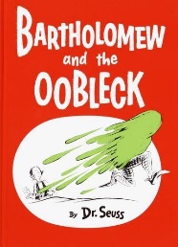 | Tudors  - Forces (Y5)  explain that unsupported objects fall towards the Earth because of the force of gravity acting between the Earth and the falling object  identify the effects of air resistance, water resistance and friction, that act between moving surfaces  recognise that some mechanisms including levers, pulleys and gears allow a smaller force to have a greater effect  CPD – Forces  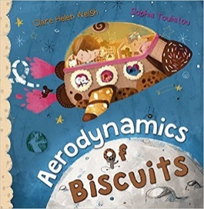 | Volcanoes and Earthquakes  British Science Week 8-17th March – Time  - Animals including humans (Y5)  describe the changes as humans develop to old age  CPD – Lifecycles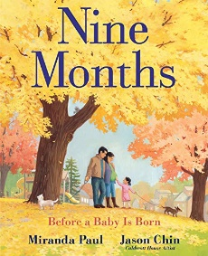 | Mining  - Living things and habitats(Y5)  describe the life process of reproduction in some plants and animals (sexual/ asexual)  CPD – Environments and Habitats  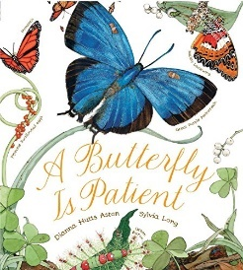 |  | European Region - Greece  - Living things and habitats(Y5)  Seashore Science lessons (PSTT)  describe the differences in the life cycles of a mammal, an amphibian, an insect and a bird  reproduction of some plants and animals  CPD – Environments and Habitats  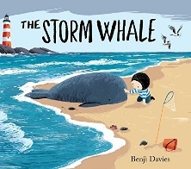
Sea Turtles 6 | WW2 A child’s war (ILP – CS)  - Light (Y6)  recognise that light appears to travel in straight lines  use the idea that light travels in straight lines to explain that objects are seen because they give out or reflect light into the eye  explain that we see things because light travels from light sources to our eyes or from light sources to objects and then to our eyes  use the idea that light travels in straight lines to explain why shadows have the same shape as the objects that cast them  CPD – Light  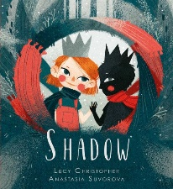 | Our UK – comparing UK regions  - Evolution and inheritance (Y6)  recognise that living things have changed over time and that fossils provide information about living things that inhabited the Earth millions of years ago  recognise that living things produce offspring of the same kind, but normally offspring vary and are not identical to their parents  identify how animals and plants are adapted to suit their environment in different ways and that adaptation may lead to evolution  CPD – Evolution and Inheritance  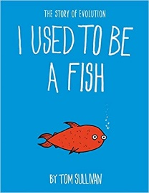 | Revolution  - Electricity (Y6)  associate the brightness of a lamp or the volume of a buzzer with the number and voltage of cells used in the circuit  compare and give reasons for variations in how components function, including the brightness of bulbs, the loudness of buzzers and the on/off position of switches  use recognised symbols when representing a simple circuit in a diagram  CPD – Electricity  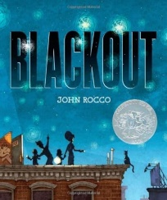 | Food, farming and Sustainable living  World trade  British Science Week 8-17th March – Time  - Animals including humans (Y6)  identify and name the main parts of the human circulatory system, and describe the functions of the heart, blood vessels and blood  recognise the impact of diet, exercise, drugs and lifestyle on the way their bodies function  describe the ways in which nutrients and water are transported within animals, including humans  (but also some Beach Science once SATS are finished)  CPD – Body Systems  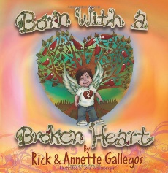 | SATS | Our Mevagissey  - Living things and their habitats (Y6) (Beach schools – PSTT lessons)  describe how living things are classified into broad groups according to common observable characteristics and based on similarities and differences, including micro-organisms, plants and animals  give reasons for classifying plants and animals based on specific characteristics  CPD – Classification  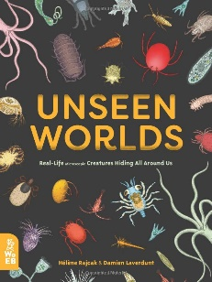.

Key stage 1 National curriculum strands
Working Scientifically | Biology Pupils should be taught to: | Chemistry Pupils should be taught to: | Physics Pupils should be taught to:
During Years 1 and 2, pupils should be taught to use the following practical scientific methods, processes and skills through the teaching of the programme of study content:  • asking simple questions and recognising that they can be answered in different ways  • observing closely, using simple equipment  • performing simple tests  • identifying and classifying  • using their observations and ideas to suggest answers to questions  • gathering and recording data to help in answering | Living things and their habitats  • explore and compare the differences between things that are living, dead, and things that have never been alive Animals, including humans  • identify and name a variety of common animals including, fish, amphibians, reptiles, birds and mammals  • identify and name a variety of common animals that are carnivores, herbivores and omnivores  • describe and compare the structure of a variety of common animals ( fish, amphibians, reptiles, birds and mammals including pets)  • identify, name, draw and label the basic parts of the human body and say which part of the body is associated with each sense.  • notice that animals, including humans, have offspring which grow into adults  • find out about and describe the basic needs of animals, including humans, for survival (water, food and air)  • describe the importance for humans of exercise, eating the right amounts of different types of food, and hygiene  Plants  • identify and name a variety of common wild and garden plants including deciduous and evergreen trees  • identify and describe the basic structure of a variety of common flowering plants, including trees.  • observe and describe how seeds and bulbs grow into mature plants  • find out and describe how plants need water, light and a suitable temperature to grow and stay healthy.  Habitats  • identify that most living things live in habitats to which they are suited and describe how different habitats provide for the basic needs of different kinds of animals and plants, and how they depend on each other  • identify and name a variety of plants and animals in their habitats, including micro-habitats  • describe how animals obtain their food from plants and other animals, using the idea of a simple food chain, and identify and name different sources of food. | Everyday materials  • distinguish between an object and the material from which it is made  • identify and name a variety of everyday materials, including wood, plastic, glass, metal, water, and rock  • describe the simple physical properties of a variety of everyday materials  • compare and group together a variety of everyday materials on the basis of their simple physical properties  • identify and compare the suit- ability of a variety of everyday materials, including wood, metal, plastic, glass, brick, rock, paper and cardboard for particular uses find out how the shapes of solid objects made from some materials can be changed by squashing, bend- ing, twisting and stretching. | Seasonal changes  •observe changes across the four seasons  •observe and describe weather associated with the seasons and how day length varies

Lower Key stage 2 National curriculum strands
Working Scientifically | Biology Pupils should be taught to: | Chemistry Pupils should be taught to: | Physics Pupils should be taught to:
Working scientifically During Years 3 and 4, pupils should be taught to use the following practical scientific methods, processes and skills through the teaching of the programme of study content:  • asking relevant questions and using different types of scientific enquiries to answer them  • setting up simple practical enquiries, comparative and fair tests  • making systematic and careful observations and , where appropriate, taking accurate measurements using standard units, using a range of equipment, including thermometers and data loggers  • gathering, recording, classifying and presenting data in a variety of ways to help in answering questions  • recording findings using simple scientific language, drawings, labelled diagrams, keys, bar charts, and tables  • reporting on findings from enquiries, including oral and writ- ten explanations, displays or presentations of results and conclusions  • using results to draw simple conclusions, make predictions for new values, suggest improvements and raise further questions  • identifying differences, similarities or changes related to simple scientific ideas and processes  • using straightforward scientific evidence to answer questions or to support their findings. | Living things and their habitats  • recognise that living things can be grouped in a variety of ways  • explore and use classification keys to help group, identify and name a variety of living things in their local and wider environment • recognise that environments can change and that this can sometimes pose dangers to living things Animals, including human  • identify that animals, including humans, need the right types and amount of nutrition, and that they cannot make their own food; they get nutrition from what they eat  • identify that humans and some other animals have skeletons and muscles for support, protection and movement.  • describe the simple functions of the basic parts of the digestive system in humans  • identify the different types of teeth in humans and their simple functions.  • Construct and interpret a variety of food chains, identifying producers, predators and prey  Plants  • identify and describe the functions of different parts of flowering plants: roots, stem/trunk, leaves and flowers  • explore the requirements of plants for life and growth (air, light, water, nutrients from soil, and room to grow) and how they vary from plant to plant  • investigate the way in which water is transported within plants  • explore the part of flowers play in the life cycle of flowering plants, including pollination, seed formation and seed dispersal. | Rocks  •compare and group together different kinds of rocks on the basis of their simple physical properties  • recognise that soils are made from rocks and organic matter  •Describe in simple terms how fossils are formed when things that have lived are trapped within rock. States of matter  •compare and group materials together, according to whether they are sol- ids, liquids or gases  •observe that some materials change state when they are heated or cooled, and measure or research the temperature at which this happens in degrees Celsius (°C),  •identify the part played by evaporation and condensation in the water cycle and associate the rate of evaporation with temperature. | Electricity  •identify common appliances that run on electricity  •construct a simple series electrical circuit, identifying and naming its basic parts, including cells, wires, bulbs, switches and buzzers  •identify whether or not a lamp will light in a simple series circuit, based on whether or not the lamp is part of a complete loop with a battery  •recognise that a switch opens and closes a circuit and associate this with whether or not a lamp lights in a simple series circuit  •recognise some common conductors and insulators, and associate metals with being good conductors  Forces and magnets  •compare how things move on different surfaces  •notice that some forces need contact between two objects but magnetic forces can act at a distance  •observe how magnets attract or repel each other and attract some materials and not others  •compare and group together a variety of everyday materials on the basis of whether they are attracted to a magnet, and identify some magnetic materials  •describe magnets as having two poles  •predict whether two magnets will attract or repel each other, de- pending on which poles are facing  Light  • recognise that they need light in order to see things and that dark is the absence of light  •notice that light is reflected from surfaces  •recognise that light from the sun can be dangerous and that there are ways to protect their eyes  •recognise that shadows are formed when a light source is blocked by a solid object  • find patterns in the way that the size of shadows change  Sound  •identify how sounds are made, associating some of them with something vibrating  •recognise that vibrations from sound travel through a medium to the ear  •find patterns between the pitch of a sound and features of the object that produced it  •find patterns between the volume of a sound and the strength of the vibrations that produced it.  •recognise that sounds get fainter as the distance from the sound source increases.

Upper Key stage 2 National curriculum strands
Working Scientifically | Biology Pupils should be taught to: | Chemistry Pupils should be taught to: | Physics Pupils should be taught to:
Working scientifically During Years 5 and 6, pupils should be taught to use the following practical scientific methods, processes and skills through the teaching of the programme of study content:  • planning different types of scientific enquiries to answer questions, including recognising and controlling variables where necessary  • taking measurements, using a range of scientific equipment, with increasing accuracy and precision, taking repeat readings when appropriate  • recording data and results of increasing complexity using scientific diagrams and la- bels, classification keys, tables, scatter graphs, bar and line graphs,  • using test results to make predictions to set up further comparative and fair tests  • reporting and presenting findings from enquiries, including conclusions, causal relationships and explanations results, explanations of and degree of trust in results, in oral and written forms such as displays and other presentations  • identifying scientific evidence that has been used to support or refute ideas or arguments. | Living things and their habitats  • describe how living things are classified into broad groups according to common observable characteristics and based on similarities and differences, including micro- organisms, plants and animals  • give reasons for classifying plants and animals based on specific characteristics • describe the life process of reproduction in some plants and animals  • describe the differences in the life cycle of a mammal, an amphibian, an insect and a bird  • recognise the impact of diet, exercise, drugs and lifestyle on the way their bodies function. Animals, including humans  • describe the changes as humans develop to old age  • identify and name the main parts of the human circulatory system, and describe the functions of the heart, blood vessels and blood  • recognise the impact of diet, exercise, drugs and lifestyle on the way their bodies function. • describe the ways in which nutrients and water are transported within animals including humans  Evolution and inheritance  • recognise that living things produce off- spring of the same kind, but but normally off- spring vary and are not identical to their parents  • recognise that living things have changed over time and that fossils provide the information about living things that inhabited the Earth millions of years ago  • identify how animals and plants are adapted to suit their environment in different ways and that adaption leads to evolution normally off- spring vary and are not identical to their parents  • recognise that living things have changed over time and that fossils provide the information about living things that inhabited the Earth millions of years ago  • identify how animals and plants are adapted to suit their environment in different ways and that adaption leads to evolution | Properties of everyday materials  • compare and group together everyday materials on the basis of their properties, including their hardness, solubility, transparency, conductivity (electrical and thermal), and response to magnets  • know that some materials will dissolve in liquid to form a solution, and describe how to recover a substance from a solution • use knowledge of solids, liquids and gases to decide how mixtures might be separated, including through filtering, sieving and evaporating  • give reasons, based on evidence from comparative and fair tests, for the particular uses of everyday materials, including metals, wood and plastic Reversible change  • demonstrate that dissolving, mixing and changes of state are reversible changes. Changes that form new materials  • explain that some changes result in the formation of new materials, and that this kind of change is not usually reversible, including changes associated with burning, and the action of acid on bicarbonate of soda. | Electricity  • associate the brightness of a lamp or the volume of a buzzer with the number and voltage of cells used in the circuit  • compare and give reasons for variations in how components function, including the brightness of bulbs, the loudness of buzzers and the on/off position of switches  • use recognised symbols when representing a simple circuit in a diagram  Forces  • explain that unsupported objects fall to- wards the Earth because of the force of gravity acting between the Earth and the falling object  • identify the effect of air resistance, water resistance and friction, that act between moving surfaces • recognise that some mechanisms, including levers, pulleys and gears, allow a smaller force to have a greater effect  Light  • recognise that light appears to travel in straight lines  • use the idea that light travels in straight lines to explain that objects are seen because they give out or reflect light into the eye  • explain that we see things because light travels from light sources to our eyes or from light sources to objects and then to our eyes  • use the idea that light travels in straight lines to explain why shadows have the same shape as the objects that cast them  Earth and space  • describe the movement of the Earth, and other planets, relative to the Sun in the solar system  • describe the movement of the Moon relative to the Earth  • describe the Sun, Earth and Moon as approximately spherical bodies  • use the idea of the Earth’s rotation to explain day and night and the apparent movement of the sun across the sky

Websites and Resources for topics:
https://www.pzaz.online
PZAZ scheme of work and resources/ CPD videos
https://explorify.wellcome.ac.uk/en/activities
Explorify has been highly recommended on all the science training I have done– excellent for quick activities that link to all Science topics. These really develop reasoning skills and discussion whilst using science language etc. My class have absolutely loved Zoom in, Zoom out and Odd one out. Quick activities that require no recording, if time is tight.
Also, suggestions for investigations etc linked to all year group topics.
https://www.reachoutcpd.com/
This site is great for support/ fast training with your subject knowledge. Training takes about an hour and covers every Science topic you will be covering. This is for teachers not children. Ideally, before teaching your next topic, do the online training as it can update and extend your subject knowledge.
https://www.liketobe.org/
You can makes links to ‘real’ scientists here that can help answer some of the questions the children ask, which you may not know the answer to. Starfish class asked an engineer, working on a space rocket, questions about rockets when we were doing our space topic. Ruth Peacey (who took the flag to the Antarctic) is on here too.
https://www.stem.org.uk/
Useful for investigation ideas, CPD and resources linked to each year groups topics. I think I have signed everyone up for this before, but you may need to create a new account or reset it.
https://www.hamilton-trust.org.uk/science
Every year group science topics are covered here, with lesson plans and ideas – although they are not all free!

