Year 1
Novel Study Curriculum
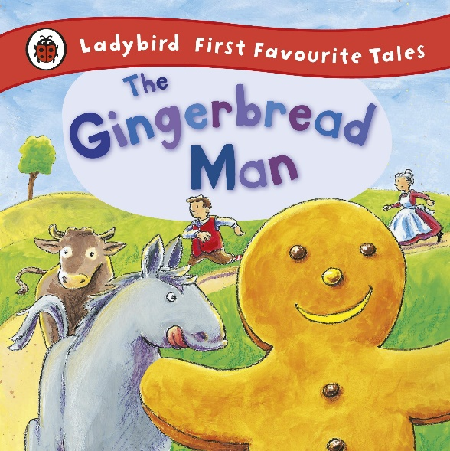
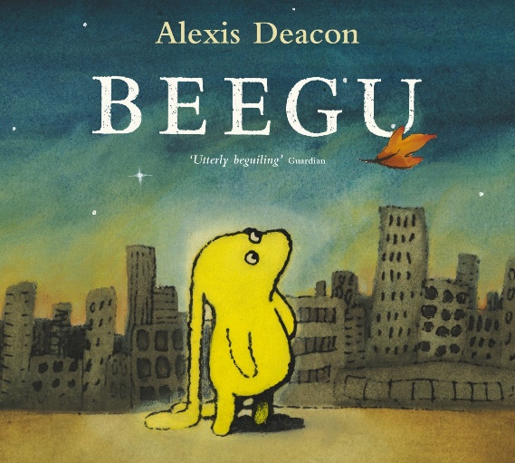

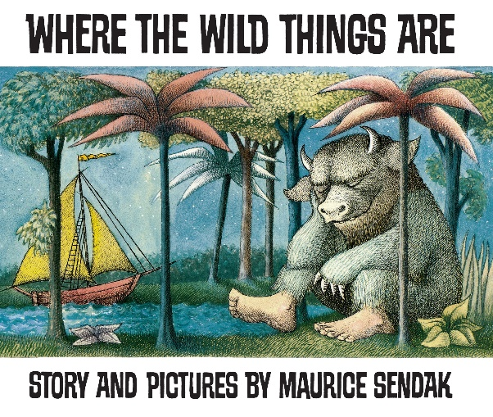
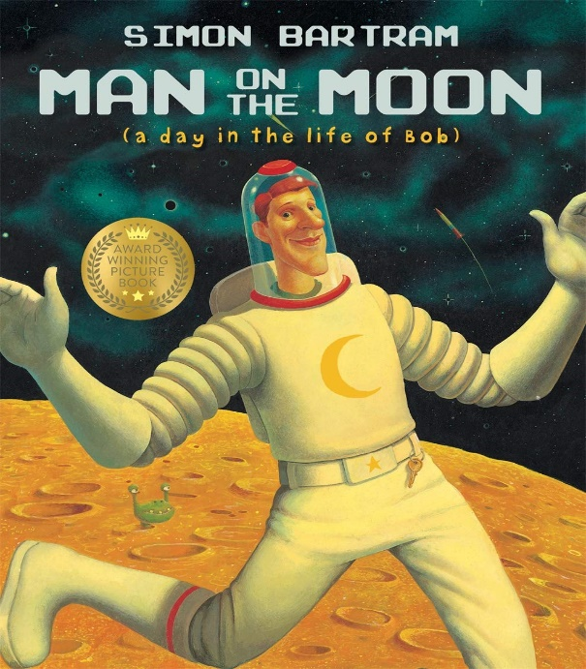

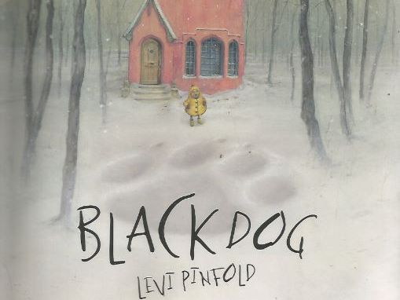
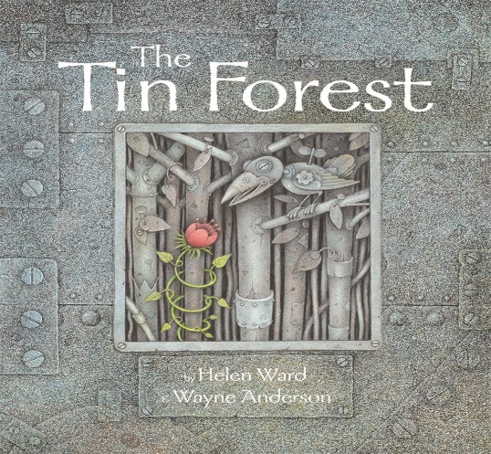

Writing Genres
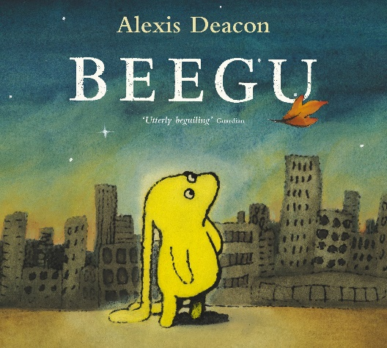
Autumn 1 Text Types Coverage:
Character Description of Beegu ‘A Lost Poster’. – extend and improve sentences using simple conjunctions. Focus on adjectives for appearance and feelings, distinguish between the two.

Letter
Notes:
- Lost Poster – extend and improve sentences using conjunctions. Focus on adjectives for appearance and feelings, distinguish between the two.
- Letter home: to mum? Or a letter to the teacher asking if Beegu can stay?

*Literacy shed planning available.

Autumn 2 Text Types Coverage:
Persuasive Letter
Poetry (Fast Poem)
Instructions (How to make Gingerbread men)
Recount
Notes:
- Write a persuasive letter. Children could study a WAGOLL from the Gingerbread man, persuading the old lady not to eat him and leave him alone. The persuasive letter the children write could be from the old lady’s perspective, trying to convince the Gingerbread man that she doesn’t want to eat him.
- Make Gingerbread men. Instructions how to make them.
- Could children recount the day the Gingerbread man escaped? They could study a WAGOLL told from the perspective of The Gingerbread man. Their version could be told from the perspective of the old lady.
Spring 1 Text Types Coverage:
Create their own ‘Wild Thing’ and produce a fact file about their Wild Thing

Character Description of Wild Thing

Setting Description of forest

Apology Letter to Mum

Notes:
- Study Wild Things in book. What would your Wild Thing look like?
- Write a description from the perspective of someone seeing your Wild Thing for the first time. Study scene where Max meets Wild Things. Look at the language - ‘roared their terrible roars and gnashed their terrible teeth.’
- Describe Max walking through the forest. Study the illustrations in the book. What could Max see? What could he hear? What could he smell?
- Write an apology letter to mum.

Spring 2 Text Types Coverage:
Postcard from the moon
Letter of Complaint
Information text (Neil Armstrong)
Short Story
Notes:
- Bob sends a postcard home to his family
- Bob is tired of space tourists - sends a letter of complaint
- Information text (Neil Armstrong)
- Short Story - Bob finally meets the aliens. Verbs to describe alien movement. Adjectives to describe appearance. Emotion words to describe how Bob feels when he sees the aliens for the first time.
Summer 1 Text Types Coverage:
Character Description/Characterisation (through the use of verbs/movement).

Write ‘Facing Fear’ story. Narrative writing.

Instructions and list writing (how to care for a dog or chosen pet).

Notes:
- Describe beast – modelled example write.
- Create own beast and describe – use this beast in independent narrative.
- Use the text to spend time looking at performance poetry through studying the song Small sings to the Black Dog.
- Instructions for how to train a pet.
- Yr 2 – similes and comparisons – use examples from text.
- Prediction Sentences: I see, I think, I wonder.
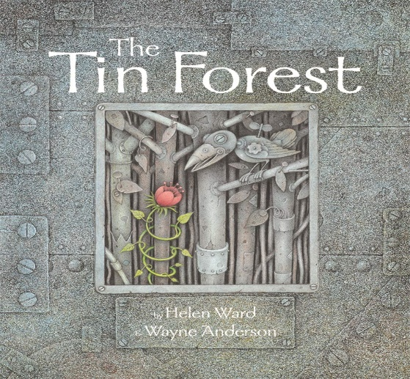
Summer 2 Text Types Coverage:
Setting Description (damaged environment)
Short Story (set in damaged environment)
Exotic Creatures Fact file
Diary Entry – A day in the old man’s life.

Notes:
- Compare the dark and light setting and draw out relevance to story/meaning.
- Draw on senses – What can the character hear? See? Smell?
- During the guided phase of setting description, use extracts from text and make minor changes, focusing on word choice and imagery.

Dolphins
Autumn 1 SPag Coverage:
- Write a simple sentence starting with a noun/proper noun
- Full stops and capital letters
- Finger spaces
- Capital letter for “I”
- Use simple past-tense verbs in a sentence
- First person, second person, third person
- Year 1: to orally use simple co-ordinating conjunctions.
- Write descriptions that include adjectives
- Suffixes – Regular plurals where you only add an “-s” or “-es” *Yr 1

Autumn 2 SPag Coverage:
- Revise basics taught in A1 (Finger spaces/Write a simple sentence starting with a noun/proper noun + Full stops and capital letters)
- Word Classes (Fast Poem will help)
- Vocab – persuasive and formal vocab
- Use connectives of sequence: first, second, then
- Use noun phrases: adjective + noun
- Determiners: the, a, an
- Sentences that end with ? !
- Write a compound sentence using the coordinating conjunction“and”
- Orally devise alliteration – a cool cat.
- Pronouns – especially first person pronouns for Diary Entry
- Suffixes of verbs, adding “-ed” or “-ing” *Yr 1
- Rhetorical questions (persuasive techniques)
- Linking adverbials (sequence adverbs) First, Second, Next etc (instructions)
- Commands using imperative verbs (instructions)

Spring 1 SPag Coverage:
- Revise key SPaG taught in Autumn Term (Finger spaces/Write a simple sentence starting with a noun/proper noun + Full stops and capital letters)
- Write a compound sentence using the coordinating conjunction“and”
- Verbs, the importance of verbs, selecting powerful verbs
- Adjectives to describe
- Similes
- Adverbs to describe character movement
- Prepositions to describe setting
- Bullet points

Spring 2 SPag Coverage:
- Revise key SPaG (Finger spaces/Write a simple sentence starting with a noun/proper noun + Full stops and capital letters)
- Vocab – persuasive and formal vocab
- Writing statements
- Form simple past tense by adding “-ed”
- What is non-fiction?
- Prefixes use of “-un” to create antonyms. Happy – Unhappy
- Suffixes – formation of adjectives adding “less” – help – helpess

Summer 1 SPag Coverage:
- Revise key SPaG
- Revise first person pronouns and possessive pronouns
- Varying sentence length – short sentences to create tension (A Peat sentence useful here)
- Verbs, the importance of verbs, selecting powerful verbs
- Adverbs to describe movement
- Similes
- Noun Phrases
- Adjectives into Adverbs – beautiful into beautifully
- Turning spoken words into inverted commas, starting with a capital letter
- Alliteration (verb + noun) dancing dandelions, hiding hyenas
- Time adverbials (explanation text)

Summer 2 SPag Coverage:
- Revise key SPaG
- Prepositions
- Pronouns - first person diary entry
- Adjectives, Verbs and Adverbs – to be used in Character Description
- Range of punctuation: ? !
- Tenses
- Suffixes of verbs, adding “-ed” or “-ing” *Yr 1
- Identifying exclamations, statements and questions.

