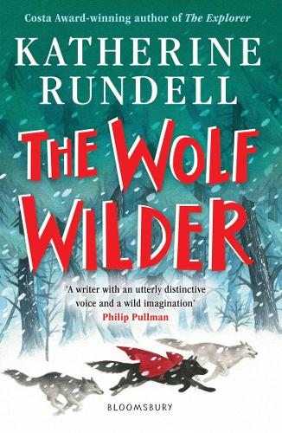
Unit Planning Overview for Wolf Wilder
The author:
Katherine Rundell is an award-winning children's writer and a Fellow in English Literature at All Souls College, Oxford. Her books have won, among others awards, the Waterstones Children's Book Prize, the Blue Peter Book Award, the Boston Globe Horn Book Award in America, the Andersen Prize in Italy and Le Prix Sorcières in France. She lives mostly in London and a little in Oxford, where she works on research into the Renaissance poet John Donne and occasionally goes climbing on rooftops late at night.
By the end of this unit I will be able to write…
- Action Scene (3rd Person, past tense).
- Persuasive Letter
- Newspaper Report
Literary devices I will be practising throughout this writing journey:
- The more, the more (Alan Peat sentence type).
- ‘Irony’ sentence (Alan Peat sentence type).
- Colons to mark the boundary between clauses.
- Hyphens for compound words to avoid ambiguity.
- Persuasive devices.
- Time adverbials.
- Repetition for effect: persuasion, suspense, emphasis.
- Personification.
- Modal verbs.
- Direct speech.
- Colon and bullet points for a list.

Other writing opportunities that will help me practise my skills:
- Instructions
- Prediction Writing (writing an effective ending to a story)

Book Blurb:
Feodora and her mother live in the snowbound woods of Russia, in a house full of food and fireplaces. Ten minutes away, in a ruined chapel, lives a pack of wolves. Feodora's mother is a wolf wilder, and Feo is a wolf wilder in training. A wolf wilder is the opposite of an animal tamer: it is a person who teaches tamed animals to fend for themselves, and to fight and to run, and to be wary of humans. When the murderous hostility of the Russian Army threatens her very existence, Feo is left with no option but to go on the run. What follows is a story of revolution and adventure, about standing up for the things you love and fighting back. And, of course, wolves.

