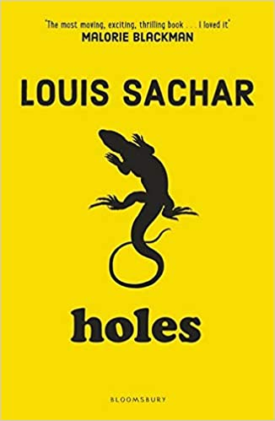
Autumn 1 Unit Planning Overview for Holes
The author:
Louis Sachar was born in New York. He was inspired to write children's books after working as a teacher's aide to gain extra credit. In 2000 Louis Sacher wrote Holes which became both an instant classic and a film starring Sigourney Weaver. Holes was his first book to be published in the UK and continues to prove popular among younger readers. Once Louis Sachar begins writing a new book he refuses to talk to anyone until it is finished and entry to his office is barred apart from his two dogs.
By the end of this unit I will be able to write…
- Character Description
- Diary Entry
- Non-Chronological Report

Literary devices I will be practising throughout this writing journey:
- Tenses
- First person, second person, third person
- Word classes
- Co-ordinating conjunctions
- Subordinating conjunctions for complex sentences
- Apostrophes
- Pronouns
- Determiners
- Adverbs to describe character movement
- Relative clauses
- Parenthesis
- Punctuating dialogue
- Similes
Yr 6 Objectives:
- Informal and formal speech: find out / discover; ask for / request; go in / enter. Using question tags for informality: He’s in your class, isn’t he?
- Use the subjunctive for formal writing: If I were you…
- Expanded noun phrase
- Semicolons to demarcate within a list
- Relative clause
- Marking parenthesis using a range of punctuation
- Layout devices such as headings, sub-headings, columns, bullet points, tables and paragraphs
- Abstract nouns
- Fronted adverbials
- Identify the subject and object of the sentence
- Tense (past, present and future)

Other writing opportunities that will help me practise my skills:
- Wild West Adventure Story

Book Blurb:
Stanley Yelnats' family has a history of bad luck, so when a miscarriage of justice sends him to Camp Green Lake Juvenile Detention Centre (which isn't green and doesn't have a lake) he is not surprised. Every day he and the other inmates are told to dig a hole, five foot wide by five foot deep, reporting anything they find. Why? The evil warden claims that it's character building, but this is a lie. It's up to Stanley to dig up the truth.

