Year 3 and 4
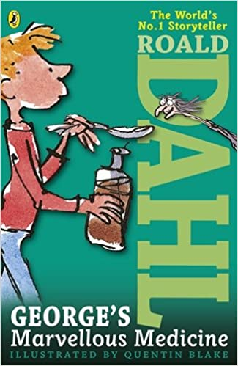
Novel Study Curriculum

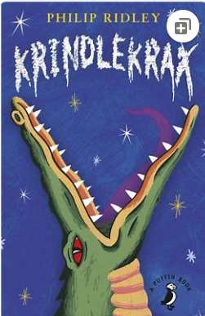

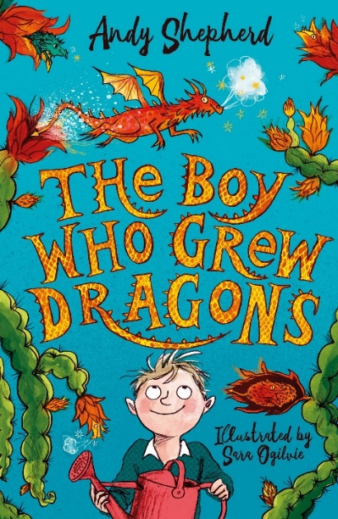
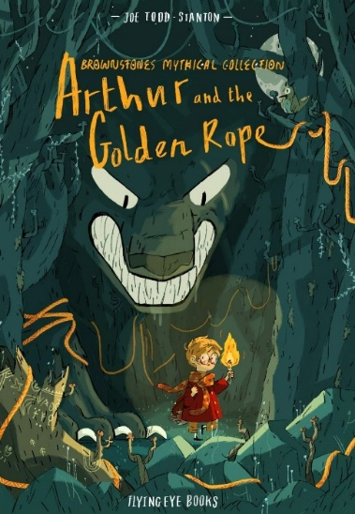

Writing Genres
Autumn 1 Text Types Coverage:
Character Description of Grandma

Third Person Narrative

Instructions

Shape Poem
Notes:
- Description of Grandma with adjectives, similes, etc. Personality and appearance. Why is Grandma the way she is?
- Instructions – How to make marvellous medicine!
- Third person narrative (including speech) *Use the brilliant speech between George and Grandma as examples. (Billy the Bully gets the medicine – write this together as shared example, then own version)
- List poem inside the shape of a medicine bottle
*Literacy shed planning available.
https://www.puffinschools.co.uk/wp-content/uploads/2019/02/Puffin-Schools-KS2-Resource-Pack-Roald-Dahl-Georges-Marvellous-Medicine.pdf

Autumn 2 Text Types Coverage:
1st Person Rescue Scene (From Lion Cub’s POV)
Balanced Argument
Diary Entry as Bertie
Description of War (setting descriptions)
Notes:
- Write the action scene where Bertie saves the Lion Cub but from the Cub’s POV. Powerful verbs/show not tell writing etc.
- Balanced Argument (Should animals be kept in captivity? Formal language)
- Diary entry from the day Bertie releases the cub. Focus on emotions and feelings.
- Write a description of the war – focus on including senses in description.
*Literacy shed planning available

Spring 1 Text Types Coverage

Persuasive Letter

Setting Descriptions

Recount

Notes:
- Persuasive letter to Mr Lace
- Setting description of Lizard Street
- First person recount - Elvis
*Literacy shed planning available
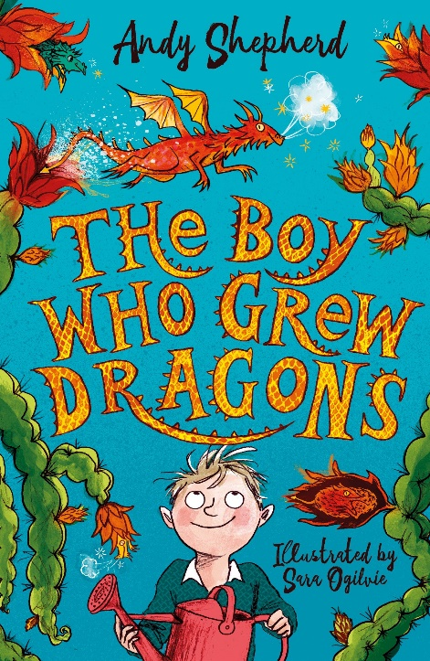
Spring 2 Text Types Coverage:
Present Tense Description
Non-Chronological Report
Write an informal letter in character
Poetry
Notes:
- Write a present tense description of the chaos in their bedroom after their own dragon hatches
- Design and create their own dragon to write an information report about
- Write a letter of apology to Grandad. Written in character as Tomas.
- Write a funny, rhyming dragon poem
- *Literacy shed planning available.

Summer 1 Text Types Coverage:
Action Sequence and fight scenes/describing villainous cats (verbs and adverbs to describe movement)
Setting Description of garden
Suspense Story (set in city)
Write speech (between cat and dog)
Biography of the Elder Paw

Notes:

- Action sequence: re-write cat fight scene with emphasis on powerful verbs and short snappy sentences. How does author show cats are afraid?
- Analyse SF Said’s description of the garden. Use it to inspire their own writing. Describe a cat moving through the garden.
- Imagine Varjak Paw meets the dog – what do they say to each other?
- Biography of Elder Paw

- *Literacy shed planning available.
Summer 2 Text Types Coverage:
First Person Adventure/Myth and Legends Story (Vocabulary, Settings, Characters, Plot, Paragraphs)
Third Person description of wolf attacking town
Newspaper Report
Persuasive Letter
Notes:
- Use images in book to inspire writing. Looks at Arthur’s conquests – can that be an inspiration for an adventure story?
- Third person description of the wolf attacking the town.
- Newspaper report of Arthur’s bravery.
- Persuasive Letter – Let me be your hero!
*Literacy shed planning available
Year 3
Autumn 1 SPag Coverage:
KS1 1 Revision:
- Write a simple sentence starting with a noun/proper noun
- Full stops and capital letters
- Finger spaces
- Orally devise alliteration – a cool cat.
- Capital letter for “I”
- Use simple past-tense verbs in a sentence
- First person, second person, third person
- Write descriptions that include adjectives
- Use co-ordinating conjunctions
Yr 3 Objectives:
- Knowing when to use “a” (preceding a consonant) and “an” (preceding a vowel or a word beginning with “h”)
- Word families for meaning, word class and spelling: solve, solution, solving, solved, solver, dissolved, soluble, insoluble
- Formation of nouns using prefixes: auto- anti- super- under
Autumn 2 SPag Coverage:
- Revise basics taught in A1
- Word Classes
- Determiners: the, a, an
- Apostrophes for omission (revision from KS1)
- Sentences that end with ? !
- Pronouns 1st and 3rd person
- Adverbs to describe character movement
- Expressing time, place and cause using conjunctions: when, before, after, while, so, because
- Expressing time, place and cause using adverbs: then, next, soon
- Word families for meaning, word class and spelling: solve, solution, solving, solved, solver, dissolved, soluble, insoluble
- Expanded noun phrases to describe
- Powerful verbs
- Word families for meaning, word class and spelling: solve, solution, solving, solved, solver, dissolved, soluble, insoluble

Year 4
Autumn 1 SPag Coverage:
Revision:
- Full stops and capital letters
- Use simple past-tense verbs in a sentence
- First person, second person, third person
- Word classes
Yr 4 Objectives:
- Using either a pronoun or the noun in sentences for cohesion and to avoid repetition
- Specific determiners: their, whose, this, that, these, those, which
- Expanded noun phrases
- Capital letters for proper nouns: names, places, days of the week, months, titles and languages
- Compound sentences using all the co-ordinating conjunctions
- Inverted commas for speech
- Paragraphs
Autumn 2 SPag Coverage:
Revision:
- Apostrophes for omission (revision from KS1)
- Pronouns 1st and 3rd person
- Adverbs to describe character movement
- Subordinating conjunctions for complex sentences
Yr 4 Objectives:
- Plural nouns of words ending in “o”: Know which words to add “s” to, which to add “-es” to and which could take either “s” or “-es
- Plurals for nouns ending with a “y”: change the “y” to an “i” and add “-es” baby – babies
- Prepositions: at, underneath, since, towards, beneath, beyond
- Possessive apostrophes for regular singular and plural nouns
- Fronted adverbials followed by a comma: prepositional phrases starting with an adjective and ending in “-ed”
- Formal and informal language

Sentence Type | Example | Rule | Link to N.C
BOYS sentence | He was a friendly man most of the time, but he could become nasty.  He could be really friendly or he could be really miserable.  It was a beautiful morning for a walk so he set off quite happily. | A B.O.Y.S sentence is a two-part sentence. The first part of the sentence always ends with a comma (,) and the last part always begins with a conjunction. | Using conjunctions, adverbs and prepositions to express time and cause p.40 (English Appendix 2) - Expressing time, place and cause using conjunctions, adverbs or prepositions (p. 76) (English Appendix 2)
Autumn Alan Peat Sentence Yr 3

Autumn Alan Peat Sentence
Sentence Type | Example | Rule | Link to N.C
2a Sentences | He was a tall, awkward man with an old, crumpled jacket.  It was an overgrown, messy garden with a leafless, lifeless tree. | A 2Ad sentence has two adjectives  before the first noun and two  adjectives before the second noun.  This sentence creates a clear picture for the  reader. | Noun phrases expanded by the  addition of modifying adjectives, nouns  and preposition phrases p.77 (English  Appendix 2)
Emotion, comma | Desperate, she screamed for help.  Anxious, they began to realise they were lost.  Happily, the astronaut stepped from the shuttle | Emotion first followed by the actions that are caused by the emotion.  Putting the word first gives more weight to the  emotion.  When teaching, provide an A-Z list of emotions the children could use. | Using fronted adverbials… using  commas after fronted adverbials p.40  Fronted adverbials p.77 (English  Appendix 2)

Spring 1 SPag Coverage: Yr 3
- Revise key SPaG taught in Autumn Term
- Verbs − Present perfect: “has/have” + past participle. She has gone to the shops instead of she went to the shops.
- Expressing time, place and cause, using prepositions: before, after, during, in, because of
- Similes
- Adverbs to describe character movement
- Show not tell writing
- Identifying all the word classes of a simple sentence
- Word families based on common words: fear, feared, fearful, fears, fearfully
- Formal language
- Complex sentences using subordinate conjunctions: until, although, even if
- Headings and sub-headings
- Exaggerated language: unbelievable, glorious, etc.
- Pattern of three for persuasion: Fun. Exciting. Adventerous!
- Rhetorical questions (persuasive techniques)

- Spring 2 SPag Coverage:
- Revise key SPaG
- Tenses
- Use a comma after a fronted adverbial phrase, prepositional phrase or adverb ending in “-ly”
- Formal language and informal
- Specific/technical vocabulary to add detail:
- Siamese cats are a variety that can live to a great age. The species has many unusual features for a feline.
- Paragraphs
- Headings and sub-headings
- To make the plural for nouns with a single vowel, ending in “f” or “-fe”, change the “f” or “-fe” to “-ves”: wolf − wolves
- Quantifiers: enough, less, fewer, lots of, none of, both, each, every, a few, neither, either, several
- Synonyms
Spring 1 SPaG Coverage: Yr4
- Revise key SPaG taught in Autumn Term
- Perspective
- Adverbs to describe character movement
- Verbs - Past perfect continuous: “had” + past participle + “-ing”
- 1st person pronouns and possessive pronouns
- Using either a pronoun or the noun in sentences for cohesion and to avoid repetition
- Adjectives ending in “-ed”: frightened, scared, etc.
- Complex sentences with subordinating conjunctions
- Powerful verbs - Find synonyms of words to up-level sentences and give a greater effect
- Poetic devices

Spring 2 SPaG Coverage:
- Revise Key SPaG
- Revise Speech and its different uses.
- Tense, Pronouns, POV
- Modal Verbs
- Know the difference between a preposition and an adverb
- Repetition to persuade
- Exaggerated language: unbelievable, glorious, etc.
- Pattern of three for persuasion: Fun. Exciting. Adventerous!
- Rhetorical questions (persuasive techniques)
- Compound nouns using hyphens
Sentence Type | Example | Rule | Link to N.C
As –ly | As the rain came down heavily, the children ran for shelter.  As the wind screamed wildly, the lost giant lumbered along the path.  As the water heats up quickly, a change of state happens called ‘evaporation’. | - The first part of the sentence opens with an action description which starts with the word As… and ends with an adverb.  The second part of the sentence is a description of a related, and often consequential, action. | Expressing time, place and cause using conjunctions, adverbs or prepositions (p. 76) (English Appendix 2) - Terminology for pupils: subordinate clause (English Appendix 2) -
Spring Alan Peat Sentence Yr 3

Spring Alan Peat Sentence Yr4
Sentence Type | Example | Rule | Link to N.C
Verb, person | Running, Sarah almost tripped over her own feet.  Tiptoeing, he tried to sneak out across the landing without waking anybody up. | A sentence starts with a verb to give it more importance.  The verb is always  followed by a comma and then a name or a personal pronoun (he, she, they, it) followed by the rest of the sentence. | Choosing nouns or pronouns  appropriately for clarity and cohesion  and to avoid repetition (p.40) (LKS2  programme of study)
If, if, if, then. | If the alarm had gone off, if the bus had been on time,  if the road repairs had been finished, then he might have got to school on time.  If I hadn’t found the watch, if the alarm  hadn’t gone off, if I hadn’t scared those burglars, then I wouldn’t be sitting here today. | Summarising a dramatic plot (key plots) at beginning or the end of a story in groups of 3.  The emphasis should be on  using the comma after each clause.  Each clause always begins with an if or  a then and each clause ends with a  comma (,) or a full stop (.) | Extending the range of sentences with  more than one clause by using a wider  range of conjunctions, including when,  if, because, although p.40 (LKS2  programme of study)

Summer SPag Coverage: Yr3
- Revise key SPaG
- Prepositions for setting descriptions
- Prepositions: next to, by the side of, in front of, during, though, throughout, because of
- Inverted commas: Place the spoken word between inverted commas. Start the sentence with a capital letter, place punctuation before closing the inverted commas. Say who said the words and place what the next person says on the next line.
- Complex sentences
- Range of sentence types and lengths (short sentences to create tension)
- The difference between a phrase and a clause
- Homophones and their meanings: bear – bare pear – pair (might want to introduce this early in year)
- Verbs − Use irregular simple past-tense verbs, awake – awoke, blow – blew
Summer SPag Coverage: Yr4
- Revise key SPaG
- Complex sentences using subordinating conjunctions
- Range of sentence types and lengths (short sentences to create tension)
- The difference between a phrase and a clause
- Heading and subheadings
- A sentence that gives three actions: Tom slammed the door, threw his books on the floor and slumped to the ground.
- Drop-in clause with an –ing verb: Tom, smiling secretly, hid the magic potion book. Place comma either side of subordinate clause.
- Starting sentence with ing – using a comma to demarcate the subordinate clause: Flying through the air, Harry chased the snitch.
- Prefixes to give the antonym: “im-”, “in-”, “ir-”, “il-”
- Verbs ending in “y”: change the “y” to an “i” and add “-es”
carry − carries

Sentence Type | Example | Rule | Link to N.C
__ing, __ed. | Walking in the bush, she stopped at the sight of a crocodile facing her.  Running near the beach, he halted as the ground gave way.  Jumping quickly through the air, she landed on her feet before sprinting away. | The sentence must begin with a subordinate clause which begins with a verb ending in ‘ing’, followed by the location of the action.  Focus on the use of prepositions in the first part of the sentence (subordinate clause) to explain where the action is happening. | Terminology for pupils: subordinate clause (English Appendix 2) - Using conjunctions, adverbs and prepositions to express time and cause. p.40 (English Appendix 2)
Doubly –ly ending | He swam slowly and falteringly.  He rode determinedly and swiftly.  He laughed loudly and heartily.  He tiptoed quietly and carefully | The sentence must end in two adverbs which add detail to and describe how the verb within the sentence is being carried out. | Expressing time, place and cause using conjunctions, adverbs or prepositions (p. 76) (English Appendix 2)
Alan Peat Summer Sentences Yr3

With a(n) action,  more action | With a smile, Greg waved goodbye.  With a weary wail, Thor launched his final attack. | This two-part sentence starts with a subordinate clause which starts with the phrase ‘With a(n)…’ followed by an action and a comma. The main clause then describes more action which occurs simultaneously. | Extending the range of sentences with  more than one clause by using a wider  range of conjunctions, including when, if, because, although p.40 (LKS2  programme of study)
Alan Peat Summer Sentence Yr4

