Mevagissey School Remote Learning Plan – January 2021
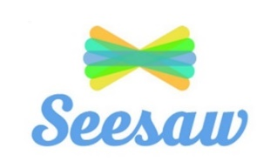
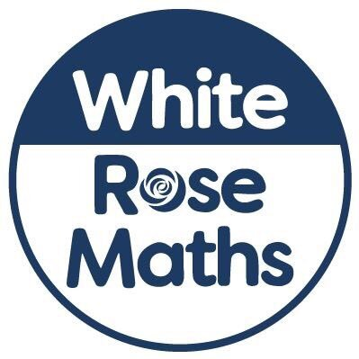
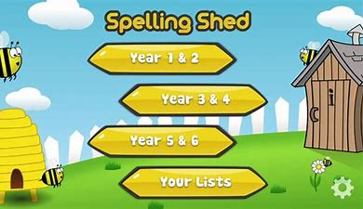

In order to ensure that learning is continued, irrespective of lockdown and self-isolation, Mevagissey Primary School has developed the following plan. This plan offers remote learning opportunities whilst also acknowledging that some households have limited access to devices and would require hard-copies of work and resources.
This plan will be applied in the following instances:
- An individual is self-isolating because of a positive test within the household;
- A group of children are self-isolating because of a case of coronavirus in the bubble;
- A whole bubble or cohort is self-isolating because of an outbreak of coronavirus
The plan complies with the expectations and principles outlined in the DFE document Guidance for Full Opening of Schools.
Software and online platforms
Within all plans, teachers will set appropriate work in-line with our current curriculum, primarily supplemented by a range of resources provided by Cornerstones, Class Novels, Oak Academy and White Rose Maths.
Children will remain in contact with their Class teacher through eSchool’s and Seesaw for EYFS children, where work will be set, marked and responded to. MS Teams may be used to make contact with groups of pupils to check on their wellbeing, in the event of an extended period of lockdown.
Teachers will set work based around their classes’ Novel Study, this is to be supported by certain lessons from Oak Academy. Oak Academy has been selected to support remote learning for a number of reasons. The Oak Academy lessons are in-line with our teaching ethos – they encourage the use of retrieval practice, explicit teaching with high quality modelling, and the use of deliberate practice.
White Rose Maths resources will be used as they are matched to our current maths curriculum model. Children are very used to seeing these resources.
Cornerstones is being used to support children to continue their topic based learning. The resources are easily accessible for parents and easy for older children to access on their own. The children are also used to the tasks and are familiar with how they are to complete them.
Teach my monster to read, AR reader, Read write Inc videos, Spelling Shed and TT Rockstars will all be utilised to support the acquisition and retention of basic core skills.

Seesaw will be the remote classrooms used to host the content for EYFS. Activities, worksheets and additional support content will be posted using this website. Pupils will be able to interact with their teachers asking questions, getting responses and having their work marked. Our school website class pages along with our social media sites will be used to celebrate learning.
In the event of any form of isolation and loss of learning caused by Coronavirus, parents must understand that engagement in home learning is compulsory, as is the expectation that Mevagissey Primary makes that provision available and accessible to all. However, if children themselves are too ill to attend then they should not be expected to engage in home learning.
In preparation for home-learning, parents and children need to receive logins and passwords for the following platforms (likewise teaching staff need to be familiar with them):
- eShools/Seesaw
- TT Rockstars/Spelling shed
- Teach my monster (KS1)
- AR reader

Worksheets and Practical Resources
If a child is isolated from school i.e. the child is sent home from school to either receive a test or self-isolate as someone in the household is being tested, they will leave school with their reading book’s, class novel and their own stationery pack. Children will have immediate opportunity to continue their learning via eSchools.

Remote Learning
The initial response to any isolation will be to provide children with home learning materials alongside their class stationery pack (if needed). In the case of whole cohort isolation, resources will be uploaded to eSchools and priority children or those known to have no access to remote learning will have packs delivered. This measure will afford teachers a short time to prepare their remote learning resources.
Pupil needs to isolate because someone in their household is symptomatic or tests positive
Ongoing Support | Safeguarding/SEND
Using eSchools, the class teacher will upload worksheets between 3pm-5pm the day before to allow parents to see the learning materials prior to supporting their child. The teacher will decide what materials are most appropriate for the individual child. This will link to the current content being delivered in the maths lesson.  If teaching input is required for core lessons, the teacher can either direct the parent to a relevant Oak National/whiterose taught session. The aim will be that the teachers provide a minimum of 3 lessons a day. An English lesson, Mathematics and an afternoon session.  Teachers will check their eSchools classroom pages at lunchtime (12.00pm) and after school (3:15pm). They will respond accordingly to any work that has been completed. Where work is incorrect, they may provide the child with follow up questions. | School office to contact parents to ensure a test has been taken and to make sure that parents know to communicate test results to secretary@mevagisseysch.org .  If child is vulnerable in any way, the DSL will ensure that appropriate agencies are notified and arrange for regular safe and well checks via a phone call from the DSL (record on CPOMS).  Where the child has not accessed the learning a text prompt will be sent to the parent reminding them that their child has learning to be completed. This will be followed up by a support call after day 2.

A group of children are self-isolating because of a case of coronavirus in their class bubble
Ongoing Support | Safeguarding/SEND
Using eSchools, the Classteacher will upload worksheets between 3pm-5pm the day before to allow parents to see the learning materials prior to supporting their child. The teacher will decide what materials are most appropriate for the individual child. This will link to the current content being delivered in the maths lesson. White Rose maths video links will be posted along with the relevant worksheets.  If teaching input is required for core lessons, the teacher can either direct the parent to a relevant Oak National/Whiterose taught session or they could use Screencastify to produce a short support video outlining how to complete the content and upload to eSchools. There will be no live lessons. | School office to contact parents to ensure a test has been taken and to make sure that parents know to communicate test results to secretary@mevagisseysch.org .  If any child is vulnerable in any way, the DSL will ensure that appropriate agencies are notified and arrange for regular safe and well checks via a phone call from the DSL (record on Cpoms). Those not engaging with home learning are to receive a phone call from a member of SLT to discuss the obstacles and support.

A whole bubble/cohort of children is isolating because of an outbreak of coronavirus or National lockdown
Ongoing Support | Safeguarding/SEND
If possible – children to be sent home with blank book and stationary if needed.  Teachers will schedule an email to the parents. In this email the teacher will discuss the remote learning arrangements and expectations. Teachers will also share a timetable of learning – this will consist of core subject lessons, a non-core lesson and a whole class reading session per day.  Using eSchools, the Classteacher will upload worksheets between 3pm-5pm the day before to allow parents to see the learning materials prior to supporting their child. The teacher will decide what materials are most appropriate for the individual child. The work set will be in line with the current planned curriculum. In the case of a National Lockdown, the curriculum delivered to Critical worker and vulnerable children in school will be the same as the work given to the children who are taking part in remote learning.  The Classteacher will share links to appropriate lessons from White Rose Maths or Oak National lessons through eSchools. Teachers will respond to learning through eSchools. They will logged into eSchools throughout the day so pupils will be able to ask questions about content that they do not understand. In the case of a National lockdown, teacher will also be in teaching so there may be a slight delay on feedback but it will be given as some point throughout the day.  For non-core lessons, resources will be uploaded to eSchools and where possible web-links to appropriate support materials will be shared. This will often be through Cornerstones and oak academy.  Time will also be scheduled for the children to watch an assembly delivered by Mr Gynn or Mrs Rees. This will encourage children to keep working, celebrate successes and promote a togetherness. These will be uploaded to eSchools.  Completed work can be: completed in their book, photographed and uploaded. Completed on the prepared work sheet and photographed and uploaded. Teachers can then review the work completed and ensure that the following day’s lesson addresses misconceptions etc. Feedback and queries can take place throughout the day using eSchools messaging. Those children that need additional support following feedback are to be contacted by the classteacher.  In the event of teachers becoming ill, support staff will be required to ‘takeover’ the eSchools account with resources being identified by other teachers/SLT in the school. | School office to contact parents to ensure a test has been taken and to make sure that parents know to communicate test results to secretary@mevagisseysch.org .  If children are entitled to benefit-related FSM contact CELT to see if support can be provided to the family.  If any child is vulnerable in any way, the DSL will ensure that appropriate agencies are notified and arrange for regular safe and well checks via a phone call from the DSL (record onCPOMS).  Those not engaging with home learning are to receive a phone call from a member of SLT to discuss the obstacles and the support needed by the family. This could then be followed up by the class teacher.  Where children would normally receive additional support from SEND agencies, the SENDCO will make arrangements for those to continue via Teams as long as the agencies engage.  The SENDCO will share appropriate Oak National SEND lessons with teachers who will disseminate accordingly.

Frequently Asked questions:

Remote teaching and study time each day

How long can I expect work set by the school to take my child each day?
We expect that remote education (including remote teaching and independent work) will take pupils roughly the following number of hours each day:
Foundation stage/Key Stage 1 | EYFS/KS1 – 3 hours a day
Key Stage 2 | Y3 – 6 - 4 hours a day

Accessing remote education

How will my child access any online remote education you are providing?
Seesaw will be used for Reception - you can use the app or web browser to access the information - https://web.seesaw.me/
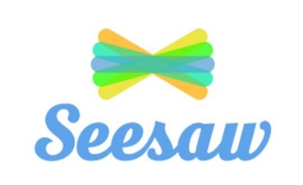
eSchools will be used for Years 1, 2, 3, 4, 5 and 6 you can use the app or web browser to access the information –

If my child does not have digital or online access at home, how will you support them to access remote education?
We recognise that some pupils may not have suitable online access at home. We take the following approaches to support those pupils to access remote education:
We understand that as a school one of the biggest barriers to accessing the home learning is often the physical equipment required. We have therefore ensured that we have adequate materials available to loan to parents.
- If you do not have a device or your device is not compatible with the home learning platform, please contact the school office on 01726 or email: secretary@mevagisseysch.org
- We will arrange a pick up time for you to collect your device and sign a contract stating that you will return the device when it is no longer required, or your child is leaving the school.
- If you continue to be unable to access the learning, we will provide you with a paper copy of the work. This can either be posted to you or collected from the school office at an agreeable time.

How will my child be taught remotely?
We use a combination of the following approaches to teach pupils remotely:
Your class teachers will provide a range of different ways to access the learning:
- recorded teaching (e.g. Oak National Academy lessons, white rose recorded video lessons, video/audio recordings made by teachers)
- printed paper packs produced by teachers (e.g. workbooks, worksheets) – if required.
- Novel study book provided to each child to support literacy planning and learning.
- Videos from other sources: YouTube, White Rose Maths and other supporting websites
- Access to online educational games – e.g. Times table Rock Stars, Spelling shed, Teach my monster to read, Languagenut, numbots.

Engagement and feedback

What are your expectations for my child’s engagement and the support that we as parents and carers should provide at home?
The children’s class teachers spend a huge amount of time preparing the materials and providing feedback and support, therefore we expect the children to engage with their home learning, daily.
We understand the challenges working parents face, therefore, we will offer weekly 20-minute teams calls with groups of children and their class teacher, where they can discuss their learning and gain support and guidance.
Our class teacher will be able to call parents back throughout the day to support with any concerns or challenges that you are facing regarding the home learning.

How will you check whether my child is engaging with their work and how will I be informed if there are concerns?
The school have set up a monitoring form that all teachers complete on a daily basis. The results of this form are sent through to the schools dedicated remote learning leader – Mrs L Rees (AHT).
If there is a period of 24 hrs without any engagement in home learning, the school will send an eschool message checking in with the child and asking if any support is needed.
Any period of more than 48hrs, where home learning is not completed, will be followed up by a call from a senior leader within the school. During the conversation the school will set out the options available. These might include: attending school due to inability to access learning, a loan of a school device or a paper copy of the materials. Support will be offered so that we can break down any barriers so that children can have access to their learning.

How will you assess my child’s work and progress?
Feedback can take many forms and may not always mean extensive written comments for individual children. For example, whole-class feedback or quizzes marked automatically via digital platforms are also valid and effective methods, amongst many others. Our approach to feeding back on pupil work is as follows:
The class teachers will be checking pupils work daily and using the information they gather to help set future learning. We will offer feedback in the following ways:
- Written comments on pupils work suggesting improvements and identifying success.
- Verbal comments and audio links.
- Whole class video feedback.
- Eschool messages to talk about work submitted.

Additional support for pupils with particular needs

How will you work with me to help my child who needs additional support from adults at home to access remote education?
We recognise that some pupils, for example some pupils with special educational needs and disabilities (SEND), may not be able to access remote education without support from adults at home. We acknowledge the difficulties this may place on families, and we will work with parents and carers to support those pupils in the following ways:
We understand the challenges that parents face when supporting children with Special educational needs.
We will ensure that all learning provided for children with additional needs is set at an appropriate level. If there are additional multi-agencies working alongside the family, we will continue to offer virtual sessions with these staff and send out paper versions of any resources required.
If your child continues to struggle to access the home learning, they will be offered a priority school place.

