Music development plan summary:
Mevagissey Primary School

Overview
Detail | Information
Academic year that this summary covers | 2024-2025
Date this summary was published | September 2024
Date this summary will be reviewed | September 2025
Name of the school music lead | Rebecca Carter
Name of school leadership team member with responsibility for music (if different)
Name of local music hub | AsOne
Name of other music education organisation(s) (if partnership in place) | CMST  Rocksteady

This is a summary of how our school delivers music education to all our pupils across three areas – curriculum music, co-curricular provision and musical experiences – and what changes we are planning in future years. This information is to help pupils and parents or carers understand what our school offers and who we work with to support our pupils’ music education.

Part A: Curriculum music
This is about what we teach in lesson time, how much time is spent teaching music.
Our school Music curriculum is taught through the scheme of Charanga which meets the requirements of the National Curriculum for Music and approaches of the Model Music Curriculum. Throughout the scheme it uses a variety of skills such as listening and appraising, composing, ensembles and performing individually and within a group. The Charanga scheme also provides a range of ideas on how to support children who need additional help or those who need further challenge. Lesson are taught weekly using interactive videos, musical instruments and teachers expertise.

How Music is taught at Mevagissey for children with Special Educational Needs (SEND)
We believe these strategies support our children with SEND to achieve using adaptive teaching. In music we remove the barriers by using each area below, in line with the teaching and learning principles at Mevagissey Primary school.

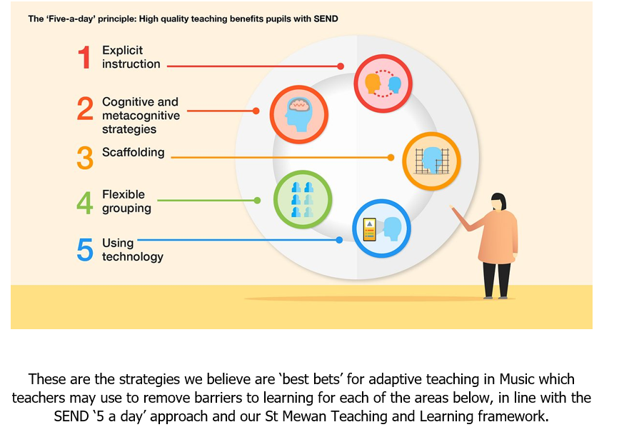
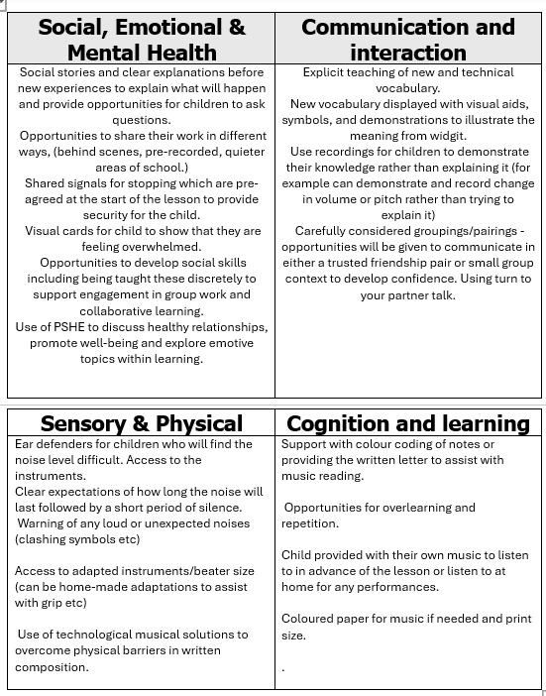

Part B: Co-curricular music
This is about opportunities for pupils to sing and play music, outside of lesson time, including choirs, ensembles and bands, and how pupils can make progress in music beyond the core curriculum.
We currently offer peripatetic lessons in piano.
These lessons can be subsidies for anyone eligible for pupil premium.
We also offer Rocksteady lessons which are paid for by the parents/guardians. The children have the opportunity to learn an instrument as part of a band. They have the choice of electric guitar, keyboard, drums or vocals.
We currently have children access these as part of our PP offer.
Reception – Yr2 can participate in a KS1 choir that focuses KS1 specific skills.
Year 1-6 have an opportunity to join the school choir, performing in concerts at school, in the community or with other local schools and at exciting venues e.g. Sea shanty festivals, local care homes and singing alongside Mevagissey Male voice choir.
All of our children have the opportunity to perform solo or with their classmates during music lessons, Christmas shows, end of year shows or singing assemblies.

Part C: Musical experiences
This is about all the other musical events and opportunities that we organise, such as singing in assembly, concerts and shows, trips to professional concerts and achieving musical awards.
At Mevagissey we run a weekly singing assembly in which all children will have the opportunity to sing as part of a large group.
We also run two separate KS1 and KS2 choirs
KS1 will perform a Christmas show in which they will perform to live audiences. And will perform individually as a group at our whole school performance.
We sing yearly alongside the Mevagissey male voice choir where the children learn different harmonies and sing with the choir as well as performing their own songs. The choir come in to do support sessions leading up to this event.
Year 6 – In Year 6 they will prepare an end of year show and perform it to a live audience.
We will also be offer Rocksteady lesson where parents can sign up with this company for children to learn an instrument as part of a band. They will have the choice of electric guitar, keyboard, drums or vocals and enjoy playing in a happy, supportive environment with their friends. Children perform every term as part of this offer.

In the future
This is about what the school is planning for subsequent years.
Next steps:
- Work closely with AsOne to increase the offer of whole school instrument lessons.
- Continue to embed the new curriculum and make any changes to units based on feedback from children and staff throughout the year.

Further information (optional)
“ASONE Perform CIC became the lead organisation for the music hub in Cornwall. The ASONE Hub is a partnership of local and regional organisations working together to support the music education of young people in Cornwall. The Hub leads on the strategic development of music education locally and works with a variety of organisations and individuals to meet local needs. We are constantly striving to ensure that we reach all children and young people, regardless of age, location or interests.”
PROGRAMME | ASONE Hub (asoneperform.com)

