Year 6
Novel Study Curriculum

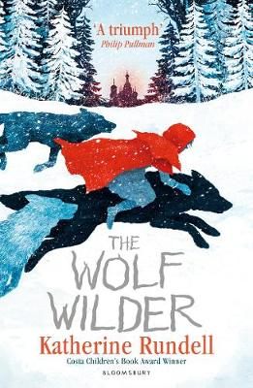
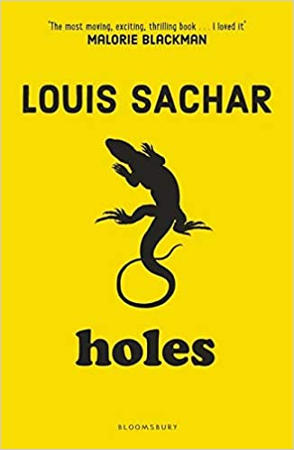

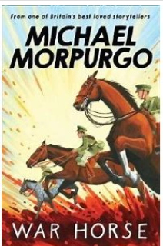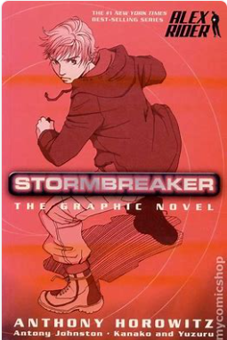
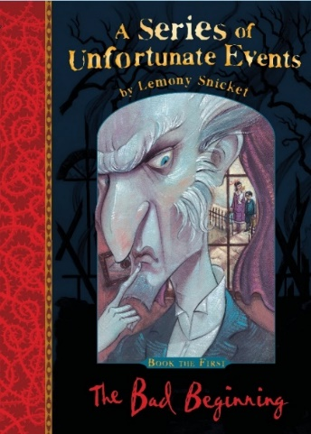
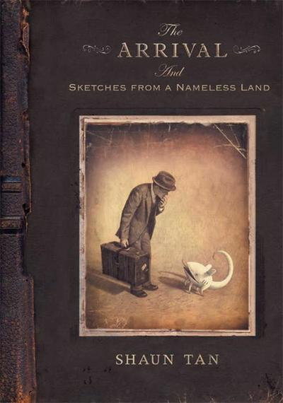

Writing Genres
Autumn Text Types Coverage:
Diary Entry

Informal Letter

Non-chronological Report

Wild West Adventure Story

Travel Brochure

Notes:
- Write events from the story in diary form, from the perspective of different characters. Include thoughts, feelings and emotions. Description of Camp Green Lake? Description of Warden?
- Write Stanley’s letter back to home from CGL.
- Non-chronological report on Yellow Spotted Lizard. ; descriptive list, relative clause, formal/technical language.
- Wild West Adventure Story. Includes dialogue to reveal character and advance action. Show not tell writing. Building suspense and atmosphere through vocab choice and sentence variation.

*Literacy shed planning available.

Autumn 2 Text Type Coverage:
Pamphlet about the requisition of horses to be used at the front line

War Letters (informal letters)

Story from an animal’s perspective

Notes:
- Diary entry from Albert’s father
- Write a Ministry of Defence pamphlet about the requisition of horses to be used at the front line
- To write in first person as Tophorn, explain life events
- Write story from animal’s perspective.
- Timeline of events of Joey’s life
- oey.
- Write from Zoey’s perspective about your own experiences of life
whilst Joey was away.

*Literacy Shed planning available

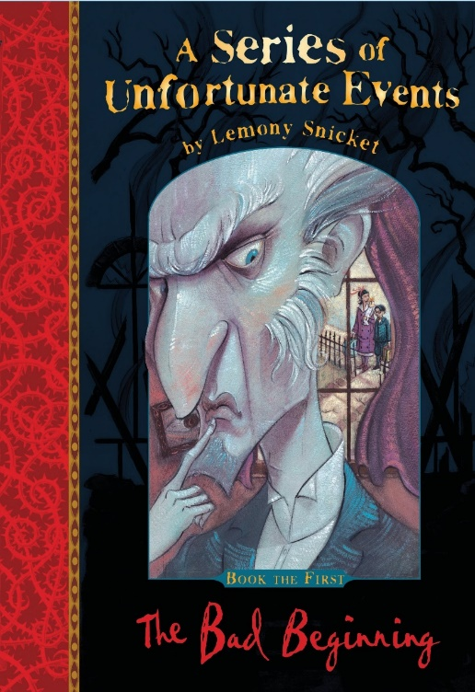
Spring 1 Text Types Coverage:
Setting Description (contrast between Justice Strauss and Count Olaf’s house)
Villainous Characters (Chr study of Count Olaf – actions to reveal character/description)
Biography for Count Olaf
Studying Lemony Snicket’s Writing Style (adverbs for possibility, directly addressing the reader, negative/bleak outlook, humour, explaining language meaning and new vocab)
Re-tell a famous fairy tale or story in the style of Lemony Snicket

Notes
• Compare and contrast settings and how it reveals information about characters. Children write scenes entering Justice Strauss house/Count Olaf’s house. The importance and significance of a creepy motif (the eye).
• Following character analysis on Count Olaf, can children write a biography for him?
• What makes Lemony Snicket’s writing style unique? Can we emulate it when re-telling a well-known story?
• *Literacy shed planning available.

- Spring 2 Text Types Coverage:
- Action Scene (3rd Person, past tense)
- Persuasive Letter
- Instructions
- Prediction Writing (writing an effective ending to a story)
- Newspaper Report

Notes:
• Study scene where Rakov burns down Feo’s house. What makes it a great actions scene? Powerful verbs, adverbs, adjectives. Colon for dramatic effect. Parenthesis to describe character and chr action. Shift in formality shown through the discovery of a ‘warning note’. Demonstrate to children how to adopt different ‘narrative voices’.
• Persuasive letter arguing that wolves should be not kept as pets. Persuasive devices. Formal language. Formal openers to express opinion. Adverbials for cohesion, link ideas across sentence and paragraphs. Modal verbs/adverbs for possibility.
• Instructions – How to be a Wolf Wilder! Rhetorical questions to engage reader. Linking words/adverbials for cohesion. Imperative verbs.
• How will the story end?
• Write a newspaper report about Feo and the village children storming the city and prison.
*Literacy shed planning available

Summer 1 Text Types Coverage:
Poem on a theme (loneliness)
Step into a picture or re-telling of Chapter 1
Letter Writing (formal and informal)
Balanced Arguments
Recount - arriving in a new, unfamiliar setting (1st Person)

Notes:

- Write a poem using images from the book. Teach metaphors/imagery
- Select a powerful image from the story – can children create a story from an image? Dragon above city image. Short atmospheric, adventure narrative.
- Letter writing – both formal and informal. Letters home to family – links to war time letters. Formal Letter – the importance of offering aid to refugees/those in need
- Presenting arguments for and against offering aid to refugees
- Diary writing – the man’s experience in his new setting and daily recounts

Summer 2 Text Type Coverage
Escape scene
Write advertisement to sell spy gadget
Setting description – use senses and imagery

Notes
- How does Anthony Horowitz create a tense atmosphere in Heaven for Cars?
- Formal letter
- Create own spy gadget and advertise on leaflet
- Persuasive advertising
- Use senses and imagery to describe villain’s lair.
- Newspaper article of events in chapter 10.

Year 6
Autumn SPag Coverage:
Revision:
- Tenses
- First person, second person, third person
- Word classes
- Co-ordinating conjunctions
- Subordinating conjunctions for complex sentences
- Apostrophes
- Pronouns
- Determiners
- Adverbs to describe character movement
- Relative clauses
- Parenthesis
- Punctuating dialogue
- Similes
Yr 6 Objectives:
- Informal and formal speech: find out / discover; ask for / request; go in / enter. Using question tags for informality: He’s in your class, isn’t he?
- Use the subjunctive for formal writing: If I were you…
- Expanded noun phrase
- Semicolons to demarcate within a list
- Relative clause
- Marking parenthesis using a range of punctuation
- Layout devices such as headings, sub-headings, columns, bullet points, tables and paragraphs
- Abstract nouns
- Fronted adverbials
- Identify the subject and object of the sentence
- Tense (past, present and future)
- Pronouns: relative and possessive

Autumn Alan Peat Sentence
Sentence Type | Example | Rule | Link to N.C
Description, which + simile sentences | Greg had huge nostrils, which made him look like a hippo.  Doctor Swogflop bathed only once a year, which meant he was as smelly as a skunk’s bottom most of the time.  The valleys have crooked ravines, which curve around like the blade of a scimitar. | The sentence is introduced by a description which is followed by a comma (,) and then the word ‘which’ followed by a simile, further describing the description.  - | Relative clauses beginning with who, which, where, when, whose, that, or an omitted relative pronoun p.78 (English Appendix 2: Year 5)
De:De Sentence | The vampire is a dreadful creature: It kills by sucking all the blood from its victims.  Snails are slow: They take hours to cross the shortest of distances.  I was exhausted: I hadn’t slept for more than two days. | Two independent clauses (they make sense on their own) are separated by a colon (:)  o The first clause is descriptive  o The second adds further detail | Use of the semi-colon, colon and dash to mark the boundary between independent clauses p.79 (English Appendix 2)

Spring SPaG Coverage:
- Revise key SPaG taught in Autumn Term
Year 6 objectives:
- Colons to mark the boundary between clauses: It’s sunny: I’m going out to play. Colons for dramatic effect.
- Semicolons to mark the boundary between clauses: It’s raining; I’m fed up
- Hyphens for compound words to avoid ambiguity: man eating shark or man-eating shark
- Personification
- Persuasive devices
- Synonyms:
- Realising that when you find a synonym, the word means something slightly different, eg,“big” and “grand”. “Grand” can mean “one thousand”, “elaborate” and “decorative”, as well as “big”.
- Antonyms to create different effects in sentences
- Antonyms: using prefixes
- Connectives to signpost and create cohesion within a text:
- order of sequence
- time connectives
- additional ideas
- space and place
- contrasting
- exemplification
- results
- to summarise
- Colon and bullet points for a list
- Repetition for effect: persuasion, suspense, emphasis
- Collective nouns
- Imperative verbs
- Modal verbs/adverbs of possibility

Spring Alan Peat Sentence
Sentence Type | Example | Rule | Link to N.C
The more, the more | The more it rained, the more depressed he became. The more the crowd cheered, the more he looked forward to the race. The more upset she was, the more she cried. | This sentence type is particularly useful when developing a character trait in a story. The first more should be followed by an emotive word and the second more should be followed by a related action. | Linking ideas across paragraphs using a wider range of cohesive devices: repetition of a word or phrase, grammatical connections and ellipsis p.79 (English Appendix 2)
‘Irony’ sentences | Our ‘luxury’ hotel turned out to be a farm building.  With dawn breaking, the ‘beautiful view’ which the brochure described, revealed itself to be a scrap-yard and a rubbish tip.  The ‘trip of our dreams’ was, in fact, our worst nightmare. | An irony sentence deliberately overstates how good or bad something is and this is placed in ‘inverted commas’.  The overstated word is then shown to be false through the remainder of the sentence which reveals the truth. | The difference between structures typical of informal speech and structures appropriate for formal speech and writing p.78 (English Appendix 2)

Summer SPag Coverage:
- Revise key SPaG
- The difference between passive and active sentence and when to use the passive
- Determiners and generalisers
- Ellipses to create suspense and to show missing words in a quote
- Metaphors
- Personification
- Simple sentences and how to embellish them
- Auxiliary verbs
- Subjunctive form

Sentence Type | Example | Rule | Link to N.C
This is that sentence | His eyes were dark tunnels.  The lake was a mirror.  The explorers knew they were standing on the shoulders of giants. | This sentence is an example of a metaphor: a figure of speech that describes a subject by stating that it is, by way of a point of comparison, the same as another otherwise unrelated object. | teachers should show pupils how to… develop their understanding of, and ability to use, figurative language’ (p.15)
Emotion – consequence | Davis was angry – he threw his toy at the wall.  The professor was inconsolable – he wept for days on end.  King Henry was furious – he ordered the execution of his wife. | This two part sentence starts with a description of a character’s emotion followed by a dash (-) and a description of a consequence of that feeling.
Alan Peat Summer Sentence

