YEAR 3/4
Long Term Plan Jellyfish Class – Cycle B
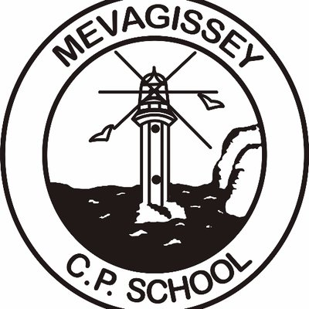

Term | Autumn 1 |  |  | Autumn 2 |  | Spring 1 | Spring 2 |  |  |  |  | Summer 1 |  |  | Summer 2
Topic | 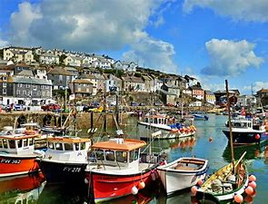  Mevagissey – A harbour to call home |  |  |   Our UK |  | 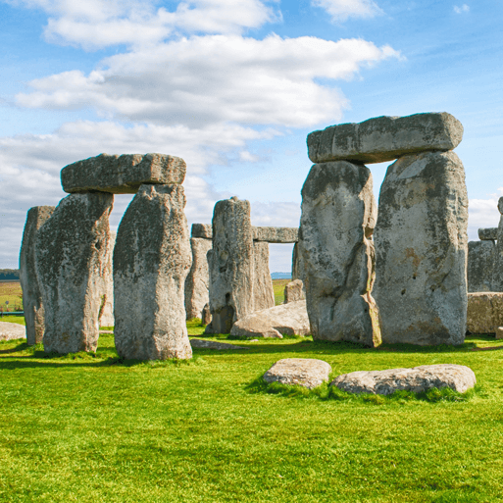  Through the ages | 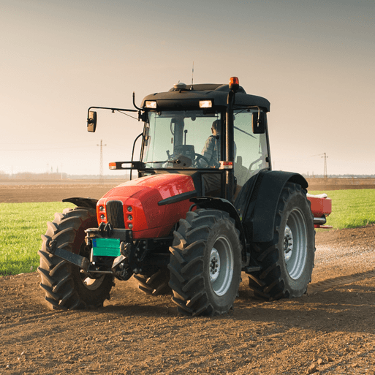  Sow, Grow and Farm |  |  |  |  | 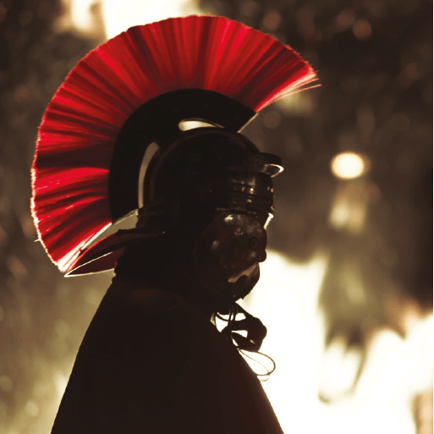  I am warrior |  |  |   Around our British isles – Scotland
Class Text/s | Reading for Pleasure:  Stuart Little – E. B. White  The Legend of Captain Crow’s Teeth – Eoin Colfer |  |  |  |  | Reading for Pleasure:  Max and the Millions – Ross Montgomery |  |  |  |  |  | Reading for Pleasure:  A Bear Called Paddington – Michael Bond
Novel Study | Georges Marvellous Medicine  Text Types Coverage:  Character Description of Grandma  Third Person Narrative  Instructions  Shape Poem  Literacy Shed:  Little Boat  Poetry:  The Sea by James Reeves |  | Butterfly Lion  Text Types Coverage:  1st Person Rescue Scene (From Lion Cub’s POV)  Balanced Argument  Diary Entry as Bertie  Poetry:  A River’s Journey by Angela’s Poems |  |  | Kindlekrax  Text Types Coverage  Persuasive Letter  Setting Descriptions  Recount  Literacy Shed:  Spy Fox  Poetry:  The Mountain by Emily Dickenson |  | The Boy who Grew Dragons  Text Types Coverage:  Present Tense Description  Non-Chronological Report  Informal Letter  Poetry  Poetry:  Linked to Novel Study |  |  |  | Varjak Paw  Text Types Coverage:  Action Sequence  Suspense Story (set in city)  Write speech (between cat and dog)  Biography of the Elder Paw  Literacy Shed:  Tamara  Poetry:  The Reader of this Poem/Elephant by Roger McGough and Rainbows/Portrait of a Dragon by Moira Andrews |  |  | Arthur and the Golden Rope  Text Types Coverage:  First Person Adventure/Myth and Legends Story (Vocabulary,  Settings, Characters, Plot, Paragraphs)  Third Person description of wolf attacking town  Newspaper Report  Persuasive Letter  Demon Dentist – Whole Class Reader  Poetry:  Revolting Rhymes
Science | Animals including humans |  |  | Forces and magnets |  | Electricity |  |  |  |  | Plants | States of matter |  |  | Living things and their habitats
Geography | No Geography focus this ½ term |  |  | Our UK |  | No Geography focus this ½ term |  |  |  | Sow, Grow, Farm |  | No Geography focus this ½ term |  |  | Around our British isles - Scotland
Design Technology | No DT focus this ½ term |  |  | .Creating structures  Castles |  | No DT focus this ½ term |  |  |  | Creating structures  Pavillions |  | No DT focus this ½ term |  |  | Electrical systems  Torches
Art and Design | Kapow: Prehistoric art |  |  | No Art focus this ½ term |  | Kapow: Every pictures tells a story |  |  |  | No Art focus this ½ term |  | Kapow: Craft |  |  | No Art focus this ½ term
History | Mevagissey- a harbour to call home. |  |  | No History focus this ½ term |  | Through the Ages |  |  |  |  | No History focus this ½ term | I am warrior |  |  | No History focus this ½ term
P.S.H.E. | Being Me in My World |  |  | Celebrating Differences |  | Dreams and Goals |  |  |  |  | Healthy Me | Relationships |  |  | Changing Me
R.E. | Buddhism:  Is it possible for everyone to be happy? |  |  | Christianity:  Has Christmas lost its true meaning? |  | Buddhism:  Can the teachings of Buddha make the world a better place? |  |  |  |  | Christianity:  What is good about Good Friday? | Buddhism:  What is the best way for a Buddhist to lead a good life? |  |  | Hinduism  Would visiting the River Ganges feel special to a non-Hindu?
Music | How does music bring us together? |  |  | Dancing in the Street |  | Stop! |  |  |  |  | Don’t Stop Believin’ | Classroom Jazz 1 |  |  | Reflect, Rewind and Replay
Maths | Place value  Addition and subtraction | Multiplication and division  Addition and subtraction |  |  | Length and perimeter  Multiplication and division |  |  |  | Fraction  Mass and capacity |  |  |  | Money  Fractions  Time | Shape  Statistics
 | Place value  Addition and subtraction | Multiplication and division Measurement - Area |  |  | Length and perimeter  Multiplication and division |  |  |  | Fraction  Decimals |  |  |  | Money  Decimals  Time | Shapes  Statistics  Position and Direction
P.E. | Ball Skills | Handball |  |  | Dance  Yr 4 Block  Go Active |  |  |  | Invasion Games |  |  |  | Cricket | Athletics
MFL  French | About me | Hobbies and pets |  |  | Where I live |  |  |  | How I look |  |  |  | Animals | Food and drink
Computing | Connecting computers  Online Safety  Purple Mash Unit 4.8  Hardware Investigations | Animation  Purple Mash Unit 4.6  Animation |  |  | Photo editing |  |  |  | Branching databases  Purple Mash Unit 3.6  Branching Databases  Purple Mash Unit 3.3  Spreadsheets |  |  |  | Programming A – Repetition in shapes  Purple Mash Unit 4.5  Logo | Repetition in games  Purple Mash Unit 3.1  Coding

