Year 2
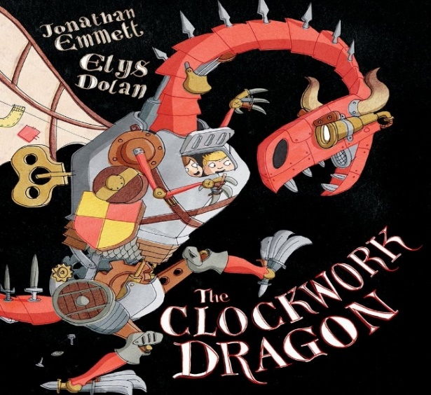
Novel Study Curriculum
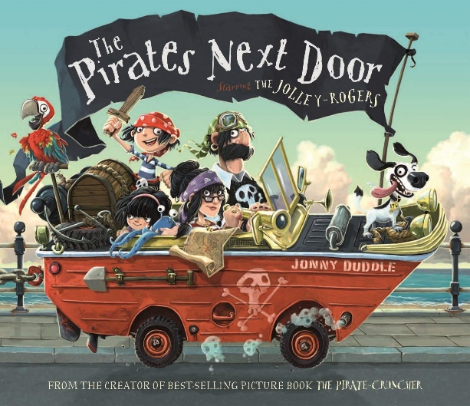

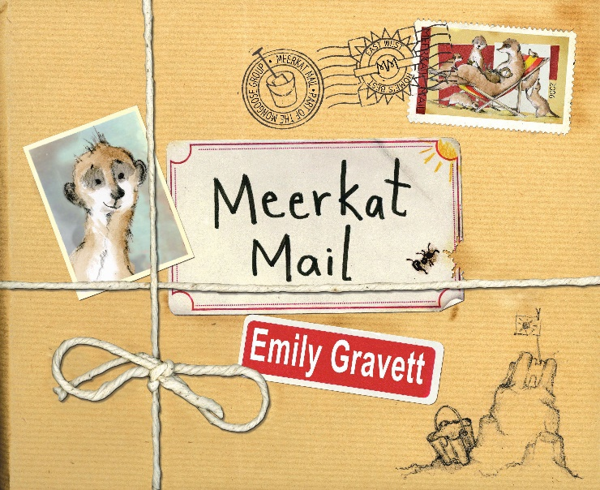
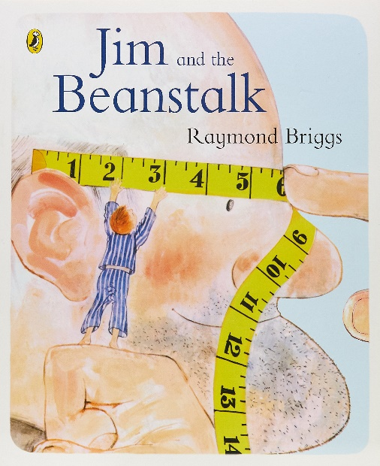

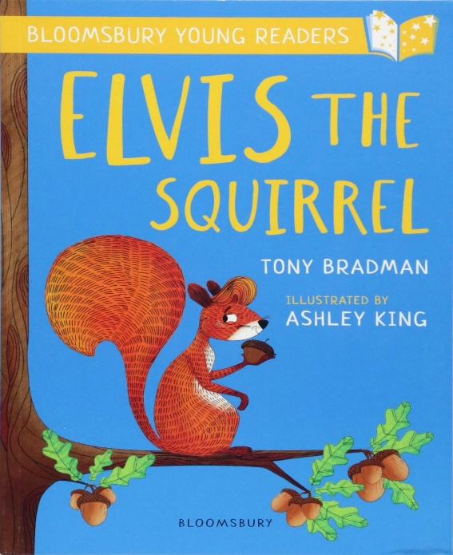
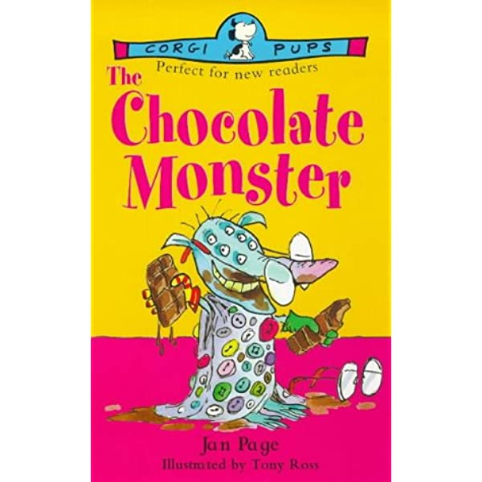

Writing Genres

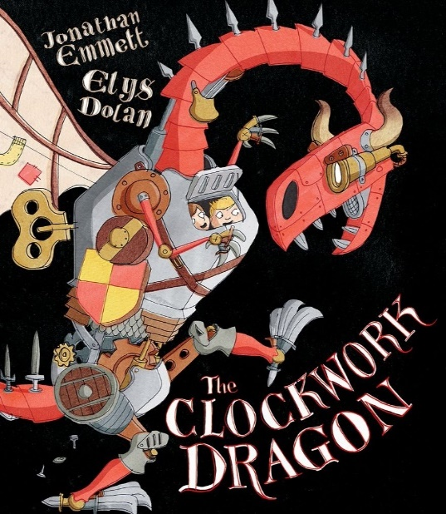
Autumn 1 Text Types Coverage:
Descriptions of Dragons - Character Descriptions (and, that, because, noun phrases) Characterisation (through verbs/movement)
Job Application (join the fight against the Dragon)
Instructions (how to defeat a Dragon)
Notes:
- Describe Dragons - use verbs to show dragon movement.
- Max applies to be a dragon hunter!
- Instructions - How to Defeat a Dragon
*Literacy shed planning available.

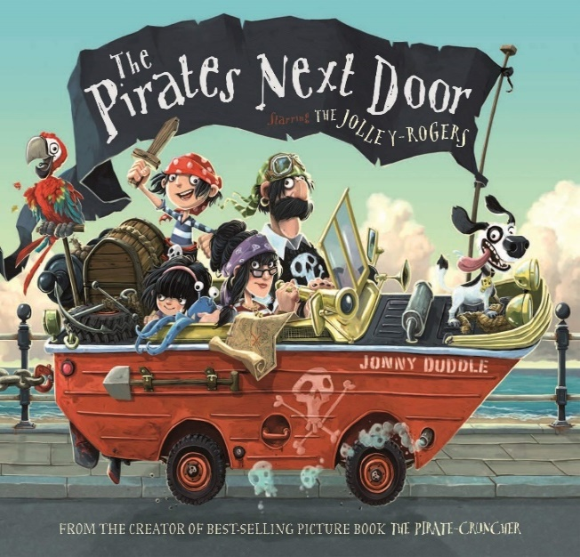
Autumn 2 Text Types Coverage:
Describe a Pirate - (Similes + Comparisons)
Setting Descriptions (use beautiful illustrations of Dull-On-Sea)
Adventure Story (Where do the children think the pirates might go when Jim Lad picks Tilda up? Explain that this is the adventure story we are going to write.)
Letter of Complaint (a neighbour complaining about Pirates)
Persuasive Letter (Matilda begging people to let them stay?
Notes:
- Describe a Pirate - Create their own? Use of similes and comparison
- Draw on senses – What can the character hear? See? Smell? - use illustration of Dull-On-Sea.
- During the guided phase of setting description, use extracts from text and make minor changes, focusing on word choice and imagery.
- Adventure story - where do Jim Lad and Tilda go at the end of the story?
- Neighbours complain about Pirates
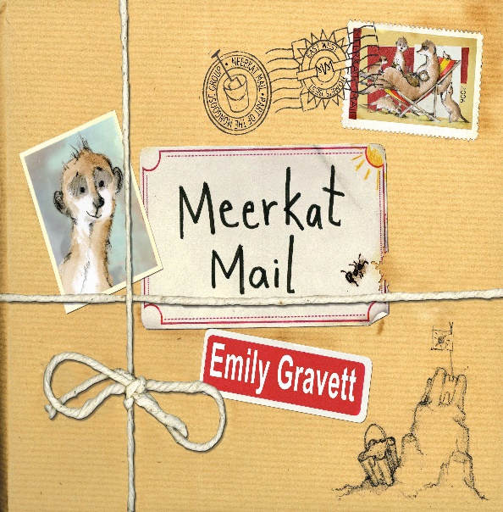
Spring 1 Text Types Coverage:
Fact-File/Non-Chronological Report on a Meerkat
Setting Description
Diary Entry (day Sunny left home)
Informal Letter
Postcards

Notes:
- Children write their fact-file on Meerkat. Model text for children to study based around the Red Hornbill, a creature that features in the story.
- Recount the Meerkat’s adventure (irst person, past tense, adjectives, extended sentences, description, senses and paragraphs)
- Sunny leaves a note to say goodbye - what would his family write back?
- Study postcards in story - write your own!

- *Literacy shed planning available.

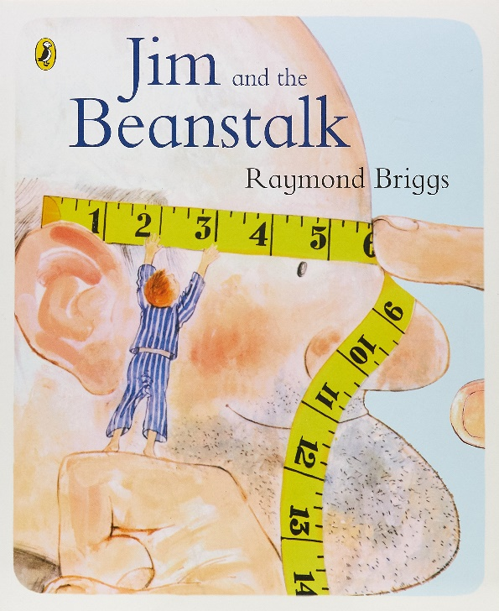
Spring 2 Text Types Coverage:
Prediction writing (what will Jim find?)
Giant Description
1st Person narrative
Newspaper Report

Notes:
- 1st person narrative - Focus on powerful verbs. Short sentences to create atmosphere and build tension. Jim climbs ‘beanstalk’ what does he find? What happens?
- Describe the Giant - reflect on his personality
- Write a report on the Jim’s adventures

- *Literacy shed planning available.

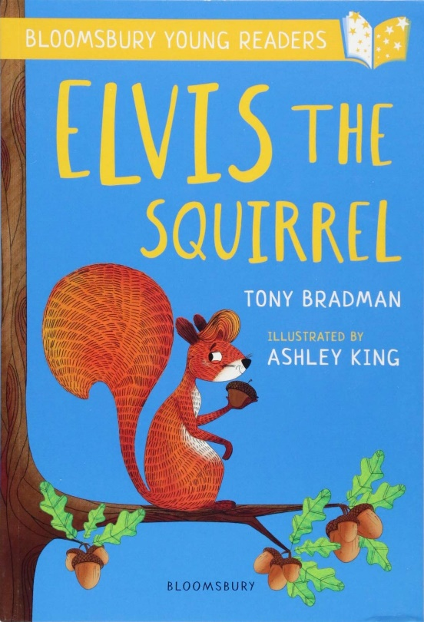
Summer 1 Text Types Coverage:
Prediction Writing
Action Sequence
Persuasive Letter
Question/Statement

Notes:
- What will happen when Elvis and Chuck try to steal the bread?
- Rewrite scene where Elvis tries to rescues Chuck
- Elvis writes a letter to ask the bird gang for their help rescuing Chuck? Model Version: Elvis writes a persuasive letter to Ronnie the Raven to let Chuck go
- Question and statement to find out about Ronnie the Raven
*Literacy shed planning available

Summer 2 Text Types Coverage:
Prediction (I see, I think, I wonder…)
Wanted Posters - The Chocolate Monster
Poetry (Chocolate Themed)
Setting Description (Using 5 Senses + prepositional phrases)

Notes:
- Hook - Trashed classroom with chocolate bars leading to cupboard. Children write predictions
- What might the chocolate monster look like? Wanted - The Chocolate Monster
- Chocolate Themed Poetry - Expanded Noun Phrase List Poem
- Setting Description of the Chocolate Monster’s Lair.

- *Literacy shed planning available
Dolphins
Autumn 1 SPag Coverage:
- Write a simple sentence starting with a noun/proper noun
- Full stops and capital letters
- Finger spaces
- Capital letter for “I”
- Use simple past-tense verbs in a sentence
- First person, second person, third person
- Yr 2: coordinating conjunctions to write compound sentences.
- Adding “-ly” to an adjective to make an adverb:
- quick − quickly
- Write descriptions that include adjectives
- Suffixes – adding “-ness” and “-er”
- Bullet Points
- Command, using the imperative form of a verb: give… take…
- Linking adverbials (sequence adverbs) First, Second, Next etc (instructions)
- Write a sentence that ends with an exclamation mark

Autumn 2 SPag Coverage:
- Revise basics taught in A1
- Word Classes
- Determiners: the, a, an
- Sentences that end with ? !
- Orally devise alliteration – a cool cat.
- Expanded noun phrases to describe (used in simple sentences).
- Prepositions to be used for Setting Description.
- Pronouns – especially first person pronouns for Diary Entry
- Suffixes – formation of adjectives by adding “-ful”. Care = Careful
- Temporal connectives: next, last, an hour later
- Similes using “like”: …like hot chilies… …cold like a glacier
- To put spoken words (found in a speech bubble) into inverted commas, starting with a capital letter.
- Subordinating Conjunctions to write complex sentences
Sentence Type | Example | Rule | Link to N.C
All the W’s | Would there ever be another opportunity like this one?  Who would take over this role now?  What if you had all of the money in the world?  Why do zebras have stripes? | Your short sentence must start with one of the following  W words:  Who? What? When? Where? Why? Would? Was? What if?  - | How the grammatical patterns in a sentence indicate its function as a statement, question, exclamation or command p. 75 (English Appendix 2) - Learn how to use sentences with different forms: statement, question, exclamation, command. p.32 (LKS2 programme of study)
Autumn Alan Peat Sentence

Spring 1 SPag Coverage:
- Revise key SPaG taught in Autumn Term
- Subordinating conjunctions to write complex sentences *Yr 2
- Verbs, the importance of verbs, selecting powerful verbs
- Adjectives to describe
- Similes
- Adverbs to describe character movement
- Apostrophe of omission
- Commands using imperative verbs (instructions)
- Commas to separate lists
- Bullet points
- Prefixes use of “-un” to create antonyms. Happy – Unhappy
- Suffixes – formation of adjectives adding “less” – help – helpess
- Temporal connectives: next, last, an hour later
- Expanded Noun Phrases
- Use simple present tense, showing subject-verb agreement: Infinitive (add “s” to the third person) I like, he/she likes, we like, they like, you like
Spring 2 SPag Coverage:
- Revise key SPaG
- Vocab – persuasive and formal vocab
- Writing statements
- Form simple past tense by adding “-ed”
- Past continues (progressive tense) He was playing at school *Yr 2
- Rhetorical questions (persuasive techniques)
- Apostrophes of omission
- Onomatopoeia
- What are synonyms?
- Temporal connectives: next, last, an hour later
- Similes using “like”: …like hot chilies… …cold like a glacier
- ? Marks
- To put spoken words (found in a speech bubble) into inverted commas, starting with a capital letter.
- Determiners and generalisers Using determiners/generalisers: most, some, all, many, much, more
Sentence Type | Example | Rule | Link to N.C
List Sentence | It was a dark, long, leafy lane.  She had a cold, cruel cackle.  It was a cold, wet, miserable Wednesday afternoon.  His hair was long, brown and unwashed. | A list sentence must have 3 or 4 adjectives before the noun. Use and between the final 2 adjectives. | Commas to separate items in a list p. 76 (English Appendix 2) - expanded noun phrases to describe and specify [for example, the blue butterfly] - p. 32 (LKS2 programme of study)
Spring Alan Peat Sentence

Summer 1 SPag Coverage:
- Revise key SPaG
- Revise first person pronouns and possessive pronouns
- Varying sentence length – short sentences to create tension (A Peat sentence useful here)
- Similes
- Noun Phrases
- Adjectives into Adverbs – beautiful into beautifully
- Turning spoken words into inverted commas, starting with a capital letter
- Alliteration (verb + noun) dancing dandelions, hiding hyenas
- Time adverbials (explanation text)
- Temporal connectives: next, last, an hour later
- ? Marks
- To put spoken words (found in a speech bubble) into inverted commas, starting with a capital letter.
- Write a statement that starts with a capital letter and finishes with a full stop

Summer 2 SPag Coverage:
- Revise key SPaG
- Prepositions
- Adjectives, Verbs and Adverbs – to be used in Character Description
- Range of punctuation: ? !
- Tenses
- Reported speech and quotations using inverted
- Formal language
- Identifying exclamations, statements and questions.
- Similes using “like”: …like hot chilies……cold like a glacier
- Use the prepositional phrases: behind, above, along, before, between, after
- Onomatopoeia
- Alliteration (verb + noun): dancing dandelions, hiding hyenas
- To put spoken words (found in a speech bubble) into inverted commas, starting with a capital letter

Sentence Type | Example | Rule | Link to N.C
Short | Oh no!  Then it happened. He stopped. Everything failed. The door opened. What’s wrong? | 1-3 word sentences possibly with an exclamation mark or question mark.  Begin to discuss exclamations, questions, statements and commands with the children. | How the grammatical patterns in a sentence indicate its function as a statement, question, exclamation or command p. 75 (English Appendix 2) - Learn how to use sentences with different forms: statement, question, exclamation, command. p.32 (LKS2 programme of study

