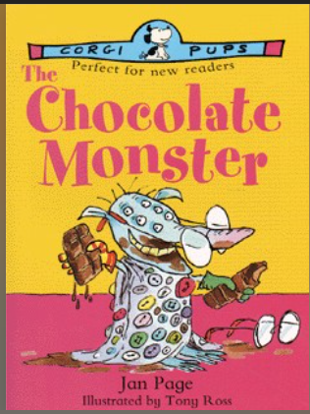
Other writing opportunities that will help me practise my skills:
- Setting Description of the Chocolate Monster’s Lair.
- Prediction (I see, I think, I wonder…)

Summer 2 - Unit Planning Overview for The Chocolate Monster
The Author:
Jan Page is a novelist, screenwriter, and television producer, whose experience ranges right across the age spectrum. Over the years, she has written hundreds of episodes of television and thirteen of her plays have been professionally staged. Jan lives in London and is co-founder of Adastra, an independent production company specializing in the children’s sector

By the end of this unit I will be able to write…
- Wanted Posters - The Chocolate Monster
- Poetry (Chocolate Themed)

Literary devices I will be practising throughout this writing journey:
- Prepositions
- Adjectives, Verbs and Adverbs
- Tenses
- Reported speech and quotations using inverted speech marks.
- Formal language
- Use a range of exclamations, statements and questions.
- Similes using “like”: …like hot chilies……cold like a glacier
- Use the prepositional phrases: behind, above, along, before, between, after
- Onomatopoeia
- Alliteration (verb + noun): dancing dandelions, hiding hyenas

Book Blurb:
Lucy Locket lost her pocket,' teases Lucy's brother, Matthew.
Lucy doesn't lose things, she insists to her brother, they just disappear! But who'd have guessed that a monster under her bed was taking them.
Finally, Lucy discovers the monster and his secret passion - chocolate. Before too long, she enters an excellent bargain with the greedy little monster. He gets all the chockie he wants, she gets all her things back...but Matthew's stuff suddenly starts vanishing

